Thesis for the degree of Master of Science in
Global IT Engineering

YOLO-Based Character Detection and Sequence Recognition on Low-Contrast Faded Bangladeshi License Plates Using Synthetic Fading Augmentation

February, 2027
Graduate School of Kyungsung University
Department of Global IT Engineering
Hasan Md Ariful
Thesis for the degree of Master of Science in
Global IT Engineering

YOLO-Based Character Detection and Sequence Recognition on Low-Contrast Faded Bangladeshi License Plates Using Synthetic Fading Augmentation

Advisor: Pham Trung Hieu
※Advisor: Christian Mulomba Mukendi
A thesis submitted to the graduate faculty of Kyungsung University in partial fulfillment of the requirements for the Degree of Master of Science in
Global IT Engineering

December, 2026
Graduate School of Kyungsung University

Department of Global IT Engineering

Hasan Md Ariful
The thesis for the Degree of Master of
Global IT Engineering
by Hasan Md Ariful
has been approved by the committee members

Chair Tahesin Samira Delwar (인)

Member Grace Firsta Lukman (인)

Member Pham Trung Hieu (인)

December, 2026
Graduate School of Kyungsung University

Master's Thesis

YOLO-Based Character Detection and Sequence Recognition on Low-Contrast Faded Bangladeshi License Plates Using Synthetic Fading Augmentation

Hasan Md Ariful

Department of Global IT Engineering
Graduate School
Kyungsung University

Advisor: Pham Trung Hieu,
※Advisor: Christian Mulomba Mukendi

Abstract
Bangladeshi license plate recognition remains challenging under degraded visual conditions, particularly when fading and low contrast reduce character visibility. This study investigates synthetic fading augmentation to improve character detection and sequence recognition using lightweight YOLO-based models.

A dataset of 4,061 clean images, comprising 27 character and token classes, was divided into 3,480 training, 363 validation, and 218 test images. Two experimental families were conducted. The first compared a YOLOv8n baseline (Model A) with an augmented model (Model B) trained using the proposed BanglaPlateFade technique with an online augmentation probability of 0.60. The second compared YOLOv5su and YOLO11n models trained with and without synthetic fading. Performance was assessed using detection metrics, exact sequence accuracy, and character error rate (CER). Additionally, 67 real faded plate images were collected, of which 64 had ground-truth labels for sequence-level evaluation.
On the clean test set, Model B achieved 95.70% mAP@0.50 and 71.73% mAP@0.50:0.95, compared with 94.13% and 70.49% for Model A. Recall improved from 89.18% to 92.49%, while exact sequence accuracy increased from 72.48% to 78.44% and CER decreased from 3.28% to 2.86%. On the real faded dataset, Model B achieved 67.19% exact sequence accuracy and 8.07% CER, outperforming Model A, which achieved 46.88% and 18.49%, respectively. In the additional experiments, synthetic fading improved YOLOv5s exact matches by 14.1 percentage points (p = 0.0225), although this result did not remain significant after Bonferroni correction. The Model A–Model B improvement was statistically significant (p = 0.001). These findings demonstrate the potential of synthetic fading augmentation for improving Bangladeshi license plate recognition under the evaluated conditions. However, the limited real faded dataset and lack of complete verified bounding-box annotations restrict conclusions about real-world detection robustness. Future work should evaluate larger annotated datasets and additional degradation conditions, including fog, rain, and nighttime environments.
Keywords: Bangladeshi license plate recognition, YOLO, synthetic fading augmentation, character detection, sequence recognition, character error rate.

Table of Contents
Abstract (in English) ⅰ
List of Tables v
List of Figures vi

Ⅰ. Introduction 1
1. Problem Statement 3
2. Research Objectives 5
3. Research Questions 6
4. Contributions of This Thesis 7
5. Thesis Organization 7
Ⅱ. Literature Review 8
1. Automatic License Plate Recognition: Overview 8
2. Plate Detection Versus Character Detection 9
3. Character Recognition and Sequence Reconstruction 10
4. Deep Learning Object Detection 11
5. The YOLO Family and Lightweight Detectors 11
6. Robustness Under Visual Degradation 12
7. Synthetic Data Augmentation and Domain Generalization 13
8. Detection and Recognition Evaluation Metrics 13
9. Research on Bangladeshi License Plates 14
10. Research Gap 15
Ⅲ. Methodology 16
1. Research Design 16
2. Data Set 18
2.1 Clean dataset 18
2.2 Synthetic-faded data 19
2.3 Real faded plates 19
3. Synthetic Fading 19
4. Severity levels 21
5. Models and Training 21
6. Evaluation Sets and Decoding 22
Ⅳ. Results and Discussion 26
1. Experimental Evaluation Overview 26
2. Object Detection Results 27
2.1 Validation performance of Model B. 27
2.2 Comparison on the Clean Test Set 27
2.3 Interpretation of Detection Performance 28
3. Models A and B 30
3.1 Graded synthetic fading 30
3.2 Clean-test sequence recognition 31
4. Real Faded Plates 32
4.1 Models A and B 32
4.2 Family 2: raw and deduplicated decoding 33
4.3 Confidence threshold (YOLOv5s_clean_fading, raw decoding) 35
4.4 Class-wise performance and limitations of rare-class estimates 36
4.5 Exploratory targeted fine-tuning 37
5. Summary of Results 39
Ⅴ. Conclusion 39
1. Introduction 39
2. Summary of the Research 40
3. Answers to the Research Questions 40
4. Summary of Major Findings 41
4.1 Object Detection Performance 41
4.2 Complete License Plate Sequence Accuracy 41
4.3 Character Error Rate 42
4.4 Evaluation on Real Faded License Plates 42
4.5 Differences Between Synthetic and Real Degradation 43
5. Research Contributions 44
6. Limitations of the Research 44
6.1 Limited Real-Faded Dataset 45
6.2 Limited Annotation for Real-Faded Images 45
6.3 Synthetic-to-Real Domain Gap 45
6.4 Limited Environmental Conditions 45
6.5 Dependence on Character Sequence Reconstruction 45
6.6 Generalization and Statistical Uncertainty 46
7. Future Work 46
8. Final Conclusion 47
References 48

Abstract (in Korean) 47
(Acknowledgements) 49

List of Tables
Table 1 Clean dataset. 18
Table 2 Summary of the real-faded evaluation set. 19
Table 3 Operations in fade_once. 20
Table 4 Fading Severity Levels Used in the Graded-Fading Test 21
Table 5 Trained models. Best epoch = highest validation fitness (0.1 × mAP@0.50 + 0.9 × mAP@0.50:0.95) on the clean validation split. 21
Table 6 Evaluation sets. 22
Table 7 Evaluation metrics and their purposes 25
Table 9 Object detection performance on the clean test set 27
Table 10 Detection performance on the synthetic-faded test set 29
Table 11 Models A and B on the 218 test images at four fading levels. 30
Table 12 Sequence recognition on the 218 clean test images, with paired statistics for B − A. 31
Table 13 Registration-number recognition on the 64 labeled real faded plates. 32
Table 14 Real faded plates, Family 2 (confidence 0.25). 33
Table 15 Paired comparison of raw predictions, fading-trained versus clean partner (64 plates). 34
Table 16 Effect of the confidence threshold on the 64 real faded plates. 35
Table 17 Selected class-wise test metrics. 36
Table 18 Controlled validation comparison for the exploratory fine-tuned checkpoint 38

List of Figures
Figure 1: Structure and character classification of Bangladeshi License Plate 1
Figure 2: License plate Detection 9
Figure 3: Character bounding boxes 10
Figure 4: Overall framework for Bangladeshi license plate character detection and recognition with synthetic fading augmentation. Top: inference. Bottom: training and evaluation. 18
Figure 5: Bengali Character Class Samples 18
Figure 6: Real Faded License Plate 19
Figure 7: One clean training image and three faded versions 21
Figure 8: mAP@0.50 on the clean and synthetic-faded test sets for the four models. 29
Figure 9: mAP@50 and recall under increasing synthetic fading severity. 31
Figure 10: Exact sequence accuracies and average sequence error rates. 32
Figure 11: Real faded plates with ground truth and the predictions of Models A and B. 33
Figure 12: Duplicate digit boxes on a real plate before and after suppression. 35
Figure 13: Exact accuracy and CER against confidence threshold. 36
Figure 14: F1 comparison for selected character and word classes. 37
Figure 15: Overall validation trade-off after targeted fine-tuning. 38

Ⅰ. Introduction

This chapter introduces the background and motivation for robust Automatic License Plate Recognition (ALPR) on Bangladeshi plates, where physical fading and wear, combined with Bangla script and scarce annotated data, cause lightweight YOLO detectors to fail. It proposes synthetic fading augmentation as a low-cost remedy and asks whether it transfers to real faded plates. The chapter also states the problem, aim, objectives, research questions, contributions, and thesis structure.
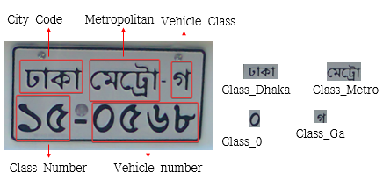
Figure 1: Structure and character classification of Bangladeshi License Plate
Automatic License Plate Recognition (ALPR) is the computer-vision task of locating a license plate within an image of a vehicle and transcribing its characters. Mature ALPR pipelines underpin intelligent transportation systems worldwide, including electronic toll collection, automated parking access, traffic-flow monitoring, stolen-vehicle detection, and electronic law enforcement. Because ALPR operates at the intersection of computer vision and public infrastructure, its reliability directly affects both operational efficiency and the fairness of automated enforcement.
Modern ALPR systems are overwhelmingly built on deep-learning object detectors. The YOLO (You Only Look Once) family of single-stage detectors is particularly popular for this task because it offers a favorable trade-off between inference speed and accuracy, enabling real-time operation on modest hardware. Recent lightweight variants — including YOLOv5s, YOLOv8s, and YOLO11n — reduce parameter counts and computational cost further, making deployment feasible at roadside units and embedded devices. A common ALPR design pattern, adopted in this thesis, treats character recognition as detection: each character class is detected individually, and the plate string is reconstructed by ordering the detected character boxes spatially. This unifies detection and recognition within a single model but introduces a sensitivity that is central to this study: if characters fade, the detector may miss them, and the reconstructed string then contains errors.
A persistent gap in the ALPR literature concerns robustness to physically degraded plates. License plates are painted metal exposed outdoors for years. Their characters progressively lose contrast as paint fades, oxidizes, and abrades — a degradation process distinct from, and in Bangladesh more prevalent than, transient weather effects such as fog or rain. Faded plates exhibit near-background character coloration, spatially non-uniform wear (some characters disappear while neighbors remain faintly visible), embossed shadows without ink, and rust or grime accumulation. These characteristics break the high-contrast dark-on-light assumption on which most detectors are trained. In this thesis, low-contrast fading denotes degradation in which the contrast between plate characters and the plate background is reduced, so that characters remain visible mainly through embossed edges or shading and are hard to distinguish by color. It is distinct from blur, occlusion, and weather effects.
Bangladesh presents a compounded challenge. Bangladeshi vehicle plates pair Bangla script (with conjunct characters and a headline stroke) with Bengali numerals and Latin letters, following the format Division [Metro] Letter – Number (e.g., ঢাকা মেট্রো-গ ৩১-৯৯৫৭). Models pretrained on Latin-script plate datasets may therefore not transfer directly. At the same time, publicly available annotated Bangladeshi plate data are scarce, and data depicting degraded plates are scarcer still: collecting and annotating large numbers of real faded plates is slow, and the resulting collections are small — in this study, 67 images, of which 64 carry verified ground-truth transcriptions.
Synthetic image augmentation offers a way out of this data scarcity. If the visual process of fading can be approximated computationally — blending character ink toward the plate background color, randomizing wear per character, and superimposing rust and grime textures — then large quantities of faded training data can be generated from an existing clean corpus at no annotation cost, since annotations are preserved by construction. Whether such synthetic fading transfers to real faded plates, however, is an empirical question and the motivating question of this thesis.

Problem Statement
Object detectors that perform well on clean images can lose accuracy on degraded ones: a benchmark study found that standard detectors fell to as little as 30–60% of their original performance on corrupted images [1]. Photographs of real vehicles can contain faded, faint, or partially obscured plate characters, so license plate recognition systems must handle such images.

For Bangladeshi plates, a character-level detector must both detect each character and reconstruct the complete plate number in the correct order. A recent Bangladeshi system that recognizes plate characters with YOLO reports full-number recognition accuracy alongside detection metrics [2]. Missing detections, duplicate bounding boxes, false positives, and incorrect classifications can each corrupt the sequence, and a single error makes the whole number wrong. In the present results, duplicate boxes affected several plates (Section 4.2).

Training with synthetically degraded images may help a detector keep working under reduced image quality. Synthetic images have been used to train license plate recognition networks successfully, provided the training images vary enough in the factors that control plate appearance [3] and a Bangla plate system used synthetic images to recognize plate classes under unfavorable and complicated conditions [4]. Robustness is commonly studied with benchmarks built from corrupted versions of standard datasets [5], [1]. However, improvement on synthetic images does not by itself show improvement on real faded plates. The mismatch between simulated and real data is known as the reality gap, and domain randomization was proposed to bridge it [6]. Separate evaluation on real faded images is therefore needed.

Detection metrics such as precision, recall, and mAP are computed against annotated ground-truth boxes, as in the standard PASCAL VOC evaluation procedure, which supplies annotated images and fixed evaluation rules [7]. The real faded dataset contains 67 cropped plate images, of which 64 have labeled plate strings. It has no verified character bounding boxes, so detection mAP cannot be computed for it. The 64 labeled images can still support a recognition evaluation, provided predictions and ground-truth sequences are processed in the same way.

The central problem addressed in this research is therefore whether training lightweight Bangladeshi license plate character detectors with synthetic fading improves recognition on real faded plates, evaluated consistently across clean, synthetically faded, and real faded conditions.

Research Objectives
The main aim of this research is to evaluate the robustness of lightweight deep-learning-based detectors for Bangladeshi license plate character detection under clean and degraded image conditions and to investigate whether training with synthetic fading improves performance on real faded license plates. The following specific objectives are defined:
- To establish a baseline performance measurement for lightweight object detectors on clean Bangladeshi license plate images.
- To generate a synthetically faded dataset from available clean license plate images and evaluate detector performance under this degradation condition.
- To compare models trained on clean data with models trained using clean and synthetically faded data.
- To evaluate the generalization of the trained models on a separate collection of real faded license plate images.
- To measure complete-sequence recognition accuracy and character-level error rates on real faded plates with available ground-truth text.
- To conduct consistent model comparisons using appropriate evaluation metrics and, where the data and experimental design permit, paired statistical tests.
- To identify the limitations of synthetic degradation, annotation availability, and post-processing in the evaluation of real-world license plate recognition.

3. Research Questions
RQ1. How does the detection performance of lightweight YOLO detectors change between clean and synthetically faded Bangladeshi license plate images?
RQ2. Does training with synthetic fading improve detection on synthetically faded images compared with training on clean images alone, without reducing clean-image performance?
RQ3. To what extent does the benefit transfer to a separate collection of real faded plates, measured by exact registration-number accuracy and character error rate?
RQ4. Are the observed differences between models statistically supported by the available paired test data?
RQ5. How do post-processing choices (duplicate suppression and confidence threshold) affect recognition on real faded plates?

4. Contributions of This Thesis
The major contributions of this thesis are as follows:
- A comparative robustness evaluation. The study compares lightweight detectors across clean and synthetically faded Bangladeshi license plate images rather than relying exclusively on clean-image performance.
- An evaluation of synthetic-fading training. The research examines whether including synthetic fading in the training process changes detection performance under degraded conditions.
- A separate real-faded recognition assessment. The study evaluates complete plate-sequence recognition on a real faded dataset with available ground-truth text, providing a separate test of generalization beyond the synthetic evaluation set.
- Multiple complementary evaluation metrics. The study considers object detection metrics alongside sequence-level and character-level measures to show how detection errors affect the final plate number.
- An emphasis on reproducible evaluation. The research identifies the importance of checkpoint provenance, consistent post-processing, reliable annotations, and per-image paired comparisons when drawing conclusions from model experiments.

5. Thesis Organization
This thesis is organized into five sections as follows.
Section I introduces the research problem, motivation, and contributions. It discusses the challenges of physical degradation model underlying the proposed method, and states the specific research objectives.

Section II reviews related work of automatic license plate recognition, deep-learning-based object detection, lightweight YOLO models, image degradation, synthetic data augmentation, and the evaluation of recognition robustness. It identifies the research gap addressed by this study.

Section III research methodology describes the datasets, preprocessing, synthetic-fading procedure, model configurations, training strategy, evaluation metrics, statistical methods, and reproducibility procedures.

Section IV experimental results and discussion presents and interprets all testing data, model comparisons, and statistical analyses. It evaluates these findings against research questions and details limitations like dataset size and synthetic degradation.
Section V conclusion and future work summarizes the main findings, addresses the research objectives, and proposes directions for improving robustness and evaluating license plate recognition under more realistic adverse-weather conditions.

Ⅱ. Literature Review

1. Automatic License Plate Recognition: Overview
Automatic License Plate Recognition (ALPR) is the task of locating a license plate in an image of a vehicle and transcribing its character sequence. Because license plates are rigid, standardized, and legally required to be visually distinctive, they function as a natural "visual license" for vehicles — a property that ALPR systems exploit across intelligent transportation applications, including electronic toll collection, parking access control, traffic monitoring, and automated enforcement. A mature ALPR pipeline typically decomposes into three stages: plate localization (finding the plate region), character segmentation or detection (isolating individual characters), and character recognition (classifying each character and ordering it into a string). Early systems performed these stages with hand-engineered features — edge detectors, color models, and projection profiles — and classical classifiers such as template matching and support vector machines. While such systems could reach high reported accuracy under controlled conditions, their reliance on high contrast, fixed viewpoints, and clean plates made them fragile in unconstrained deployment.
The deep-learning era fundamentally changed this. Convolutional neural networks (CNNs) replaced hand-crafted features, and the introduction of general-purpose object detectors — R-CNN and its descendants [8], [9] and the YOLO family of single-stage detectors [10]— enabled researchers to treat both plate localization and character recognition as unified detection problems. Two influential works shaped the modern detection-based paradigm that this thesis adopts. [11] demonstrated segmentation- and annotation-free plate recognition in which characters are localized and classified directly by a deep detector, with a failure-identification mechanism rejecting low-confidence reads. [12] Built a complete layout-independent ALPR system on the YOLO detector, combining plate detection, layout classification, and character recognition with post-processing rules, achieving an average end-to-end recognition rate of 96.9% across eight public datasets — outperforming both prior academic systems and commercial engines on several of them.

2. Plate Detection Versus Character Detection
A useful distinction in the ALPR literature separates plate detection (one bounding box per plate) from character detection (one bounding box per character). Plate detection is the more widely studied problem and is now considered nearly solved for high-quality imagery: modern detectors routinely exceed 95% mean average precision on standard benchmarks. Character detection is harder and less standardized. Characters are small objects occupying few pixels; they repeat identical shapes across plates (e.g., the digit ১ appears in most plates), creating systematic class imbalance; and their spatial arrangement carries the sequence semantics, so a detector that misses, duplicates, or misorders characters corrupts the final string even when per-character accuracy is high.

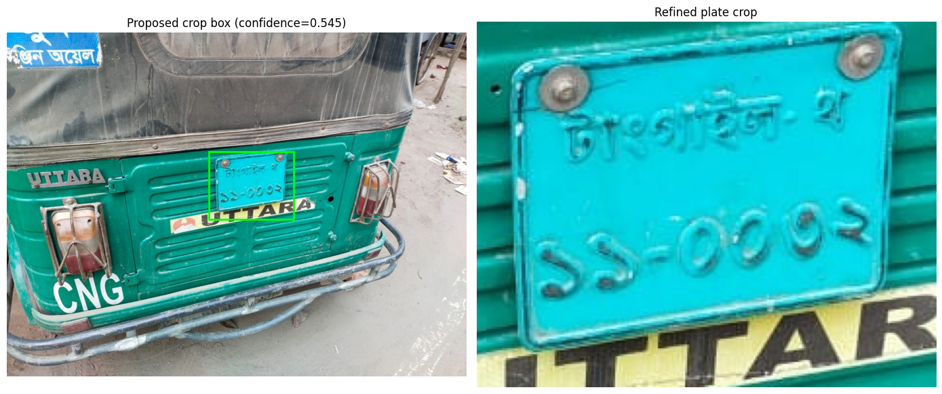
Figure 2: License plate Detection
The detection-based character approach has two practical attractions. First, it requires only bounding-box annotations of the kind produced by standard tools, avoiding the segmentation masks needed by pixel-level methods.

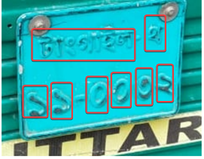
Figure 3: Character bounding boxes

Second, recognition becomes layout-independent: the same detector trained on character boxes can read plates of different formats by ordering boxes spatially, without a format-specific segmentation module [12]. The cost, as [11] observed, is sensitivity to image quality: when characters fade toward the background, character-level recall degrades discontinuously, and sequence accuracy collapses with it. This trade-off annotation simplicity and layout independence on one side, degradation sensitivity on the other — motivates the robustness focus of this thesis.

3. Character Recognition and Sequence Reconstruction
Sequence reconstruction from detected characters is a distinct sub-problem with three practical components. First, detected character boxes must be ordered (typically left-to-right by center-x coordinate, with line grouping for two-line plates). Second, duplicate suppression is required because detectors frequently emit multiple overlapping boxes for the same character; naive argmax-per-position decoding then produces spurious repeated characters in the output string. Third, normalization must reconcile formatting differences between prediction and ground truth — spacing, dash placement, and the choice of Bengali versus Arabic-Indic digit glyphs — without erasing semantically meaningful characters such as leading zeros.

An alternative lineage avoids detection-based reconstruction entirely by treating OCR as sequence generation. Recurrent architectures with connectionist temporal classification [13] and, more recently, vision-encoder–decoder transformers have been applied to cropped plate images. In the Bangla context, a recent framework paired YOLOv8-based localization with a ViT–BanglaBERT vision–language OCR stage, reporting a character error rate of 0.1323 on Bangla plate text reporting a character error rate of 0.1323 on Bangla plate text while noting that the underlying localization training data were predominantly daytime imagery [14]. Sequence-generation recognition is a genuine competitor to detection-based reconstruction, and this thesis treats it as future work (see Section 6); the present study deliberately retains the detection-based design because robustness of the detector itself, under fading, is the object of study.

4. Deep Learning Object Detection
Two-stage detectors such as Faster R-CNN [9] generate region proposals before classification and remain strong accuracy references, but their two-pass architecture is expensive for real-time use. Single-stage detectors — YOLO [10], SSD, and RetinaNet [15], via focal loss — predict boxes and classes in a single forward pass, trading a modest accuracy penalty for an order-of-magnitude speed advantage. Feature pyramid networks [15] addressed the small-object weakness of early single-stage detectors by building multi-scale feature hierarchies — a capability of direct relevance to character detection, where characters occupy tens of pixels. Transformer-based detectors such as DETR [16], ECCV removed hand-designed anchors and NMS at further computational cost; for lightweight deployment scenarios, however, convolutional single-stage detectors remain the dominant engineering choice.

5. The YOLO Family and Lightweight Detectors
The YOLO family evolved rapidly. YOLOv1 [10] introduced unified detection; YOLOv2/YOLO9000 [17] added anchor boxes and multi-scale training; YOLOv3 [18] introduced multi-scale prediction heads at three resolutions; YOLOv4 [19] systematized the "bag of freebies" training tricks; YOLOv5 [20] (Ultralytics, software release without a formal paper) repackaged the recipe in PyTorch and became the de facto community standard; YOLOv7 [21] and the anchor-free YOLOv8 [22] refined the architecture with decoupled heads and distribution-focal-loss regression; and YOLO11 targets improved accuracy–parameter efficiency for edge deployment.
Two properties of this lineage matter for the present study. First, the small-model variants used here (YOLO11n, YOLOv8n, and YOLOv5s) have checkpoints of roughly 5 to 18 MB, which makes them candidates for roadside deployment in resource-constrained settings, although inference speed was not measured in this study. Second, successive YOLO releases differ less in fundamental architecture than in training recipes and head design; a robustness benchmark across three family members (YOLOv5s, YOLOv8n, and YOLO11n) is therefore more informative than a single-model study, because conclusions about degradation and augmentation can be checked for family-level generality rather than single-checkpoint idiosyncrasy. This cross-family design follows comparative ALPR studies that evaluate several YOLO generations on the same data [23].

6. Robustness Under Visual Degradation
A substantial body of work establishes that deep detectors are brittle under distribution shift. Michaelis [1] systematically benchmarked object detection under corruptions — noise, blur, weather, digital artifacts — at multiple severities and showed consistent, sometimes catastrophic, mAP degradation that generic ImageNet training does not prevent. For ALPR specifically, the most relevant degradations are contrast loss, blur, and illumination change, and the most studied real-world correlate is adverse weather. The canonical restoration line of work — dark-channel-prior dehazing [1] and its learned descendants — treats weather degradation as an image-formation problem to be inverted before recognition.
The degradation addressed in this thesis is fundamentally different in kind. Fading of painted plates is material and irreversible: ink chemically or mechanically lost, per-character and non-uniform, often accompanied by rust and grime. No restoration algorithm can recover information that is physically absent from the plate surface — a faded plate photographed perfectly is still a faded plate. This distinguishes the present problem from fog (a transient atmospheric veil that restoration can largely remove) and aligns it more closely with the low-visibility character-degradation problem. Notably, prior Bangla work targeting weather robustness has simulated fog by augmentation or dehazing pre-processing [24] but among the studies reviewed here, none evaluated whether fading-trained models transfer to physically faded plates.

7. Synthetic Data Augmentation and Domain Generalization
Synthetic augmentation as a remedy for data scarcity has three established strategies. Domain randomization [6] randomizes rendering parameters so that the real world falls within the training distribution. Style transfer and image-to-image translation — CycleGAN and successors [25]— learn a mapping between two image domains from unpaired examples; with only dozens of real target-domain images, this becomes fragile, though patch-based training can partially compensate. Physics- or phenomenology-inspired procedural augmentation — directly simulating the degradation operator on clean images — is the simplest and, where the degradation is well-characterized, the most controllable: annotations are preserved by construction, severity is continuously tunable, and unlimited variants can be generated.
For ALPR, procedural augmentation has an additional appeal: plates are manufactured objects whose degradation process (ink fading toward substrate color, per-glyph wear, surface corrosion) is visually parametrizable. The key open question — and the empirical core of this thesis — is the synthetic-to-real gap: whether a detector trained on procedurally faded plates generalizes to plates whose fading arose from years of physical exposure, with lighting, embossing shadows, and grime that the simulation does not model. Domain-generalization theory and practice both suggest the answer is data- and task-dependent and must be established empirically per task; this study provides that empirical test for the Bangladeshi setting.

8. Detection and Recognition Evaluation Metrics
Detection performance is conventionally reported as precision, recall, and mean average precision (mAP) under the COCO protocol [26] with mAP@0.50 (IoU threshold 0.5) and mAP@0.50:0.95 (averaged over IoU 0.5–0.95) distinguishing coarse from strict localization. PASCAL VOC [27] established the IoU-based matching protocol these metrics inherit.
Recognition of full plate strings requires sequence-level metrics distinct from detection metrics. The character error rate (CER) is the Levenshtein edit distance [28] between predicted and reference strings normalized by reference length; mean per-image CER must be distinguished from CER over concatenated sequences. Full-sequence exact accuracy — the proportion of plates whose entire string matches exactly — is the deployment-relevant metric and is strictly harsher than CER, since a single wrong character fails the whole plate. When comparing two models on the same test images, paired analyses are appropriate: McNemar's test on per-image exact-match discordance [29] and paired bootstrap confidence intervals resampling images [30]. Treating individual characters as independent observations would violate pairing and inflate significance; this thesis therefore evaluates paired per-image outcomes throughout.

9. Research on Bangladeshi License Plates
Research on Bangla license plates is, as a recent comprehensive study notes, "relatively recent and limited" [14]. Early morphology-based methods achieved approximately 85% accuracy but were sensitive to dirt and color variation; subsequent work introduced CNN-based recognition and the first public Bangladeshi datasets, including the LPDB collection, with character recognition rates around 95% reported for Bangla-specific OCR engines [14]. The current state of the art combines YOLO-family localization with transformer-based text extraction: a YOLO–transformer hybrid reporting 96.5–96.9% detection accuracy and 89.96% end-to-end text recognition on a merged dataset of 40,000 collected and 70,000 synthetic plates [23]; a YOLOv9-powered Bangla recognition study [31]; and the YOLOv8m + ViT–BanglaBERT framework described in Section 3. A community pipeline fine-tunes YOLOv8 for plate detection with EasyOCR for Bengali text [32]. Public data resources include the Bangladeshi License Plate Recognition Dataset [33] used in this thesis.
Across this body of work, three gaps are visible. First, reported accuracies are overwhelmingly on clean or mildly degraded imagery; weather robustness is typically addressed via fog simulation or restoration pre-processing, not material fading. Second, evaluations are almost exclusively within-dataset; transfer to independently collected, physically degraded plates is rarely tested, and small external test sets are seldom accompanied by manually transcribed ground truth. Third, the interaction between detector post-processing — confidence thresholds, duplicate suppression, ordering — and end-to-end sequence accuracy is reported sparsely, despite its practical importance in detection-based ALPR. This thesis addresses these gaps in part, by comparing detectors across clean, synthetic, and real faded conditions on a small real set.

10. Research Gap
Across this body of work, five gaps are visible. First, evaluation on clean images alone does not establish how well a detector will perform when the visual characteristics of the input change. Robustness should therefore be measured directly on degraded test images.
Second, synthetic data augmentation provides a controlled means of introducing degradation during training, but its benefit depends on the transformation and the relationship between the synthetic and target domains. Performance on synthetic images cannot be assumed to predict performance on naturally degraded images.
Third, object detection metrics and sequence-recognition metrics measure different aspects of an ALPR system. A detector may localize most characters correctly but still produce an incorrect plate string because of missing detections, duplicate predictions, classification errors, or incorrect ordering.
Fourth, fair comparison requires consistent evaluation protocols. Differences in data splits, checkpoint identities, confidence thresholds, post-processing, and normalization can make apparently comparable results inconsistent.
Finally, evaluating real faded images is difficult when annotations are incomplete. Ground-truth plate strings allow sequence recognition evaluation, but they cannot replace the character-level bounding boxes required to calculate standard object detection metrics (such as precision, recall, and mAP).
Based on these issues, the present study investigates two experiment families using clean and synthetic-fading evaluation conditions and supplements the detection benchmark with recognition evaluation on a separate collection of real faded plates. The design enables the study to examine whether synthetic-fading training improves detection on the selected synthetic degradation and whether corresponding benefits are observed in real-faded sequence recognition.
The contribution is an empirical comparison under the available dataset and evaluation conditions. The study does not claim that synthetic fading solves all adverse-weather problems or that the results establish generalization to every real-world environment. Instead, it seeks to quantify performance differences, assess their consistency, and identify the limits of the available evidence.

Ⅲ. Methodology

This chapter presents the methodology used to investigate the robustness of deep learning-based Bangladeshi license plate detection under image degradation, particularly synthetic fading. The study evaluates whether training object detection models with faded license plate images improves their performance on degraded images compared with models trained on clean images.

The methodology consists of dataset preparation, annotation processing, synthetic fading generation, model training, evaluation on clean and synthetic-faded test sets, and additional recognition experiments using real-faded license plate images. Performance is assessed using object detection metrics and sequence-level recognition metrics. The experimental design follows the general principles of object detection evaluation and robustness testing under image corruption [10], [5].

Research Design
Lightweight YOLO detectors read a plate by detecting each character as one of 27 object classes. The manipulation is the training data: clean images only, or clean plus synthetically faded images. Every model is tested on clean images, synthetically faded images, and real faded plates. Two experiment families were run, and their results are never pooled.
Family 1 consists of two YOLOv8n models (Model A, baseline; Model B, trained with BanglaPlateFade, p = 0.60). Family 2 consists of YOLOv5su and YOLO11n, each trained on clean data or on clean plus faded copies. Model A (baseline) is trained on the clean training images only. Model B (synthetic fading) is trained on the same images, but each image is randomly faded with probability 0.60 at every epoch. All other settings are identical, so comparing A with B isolates the effect of fading during training. In Family 2, the same contrast is expressed by the model names: _clean models are trained on clean images only, and clean_fading models also see faded copies of the training images.
This research adopts a quantitative experimental design. Deep learning object detectors are trained using alternative training datasets and evaluated under clean and degraded image conditions. The principal comparison is between a baseline model trained using clean images and a corresponding model trained using a combination of clean and synthetically faded images.

The research is organized around three experimental components:

- Clean-image detection: Evaluate model performance on images representing the original, relatively clear dataset.
- Synthetic-fading robustness: Evaluate the trained models on a held-out test set containing synthetically faded images.
- Real-faded recognition assessment: Compare predicted license plate character sequences against manually prepared ground-truth transcriptions for a separate set of real-faded plate images.
The first two components measure object detection performance. The third measures the correctness of the resulting character sequences and must be interpreted separately because the real-faded dataset does not currently have verified character-level bounding-box annotations.

Figure 4 outlines the research workflow. Clean images are preprocessed, optionally faded, and used to train the detectors. The trained models are then tested on clean, synthetic-faded, and real faded images, scored with the metrics that the available labels allow, and compared with paired statistical tests.

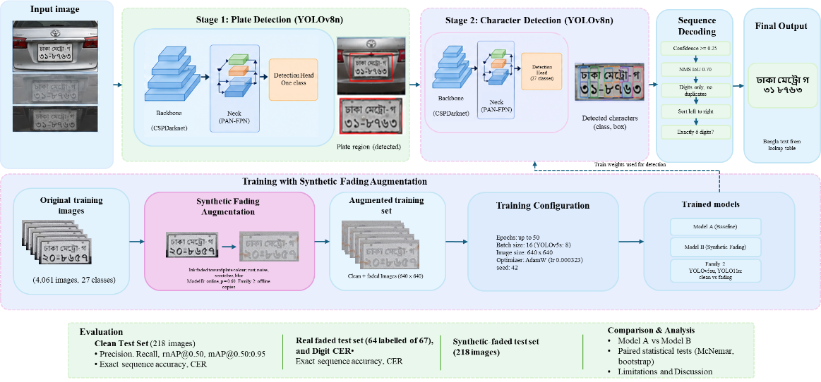 | Figure 4: Overall framework for Bangladeshi license plate character detection and recognition with synthetic fading augmentation. Top: inference. Bottom: training and evaluation.

Data Set

2.1 Clean dataset
The clean data are Pascal VOC annotations converted to YOLO format, using the splits supplied by the source Kaggle syednahinhossain/bangladeshi-license-plate-recognition-dataset [33].

Table 1 Clean dataset.
Split | Images | Annotated instances
Train | 3,480 | 30,604
Validation | 363 | 3,180
Test | 218 | 1,921

The 27 classes are the digits 0–9, twelve Bengali series letters (ka, kha, ga, gha, ca, ja, ta, da, na, ba, va, ha), and five-word classes (metro, dhaka, khulna, chattogram, jashore). Classes are strongly imbalanced: in training, digit 1 has 4,524 instances and metro 3,192, but na has 32, va 36, ka 44, and da 48.

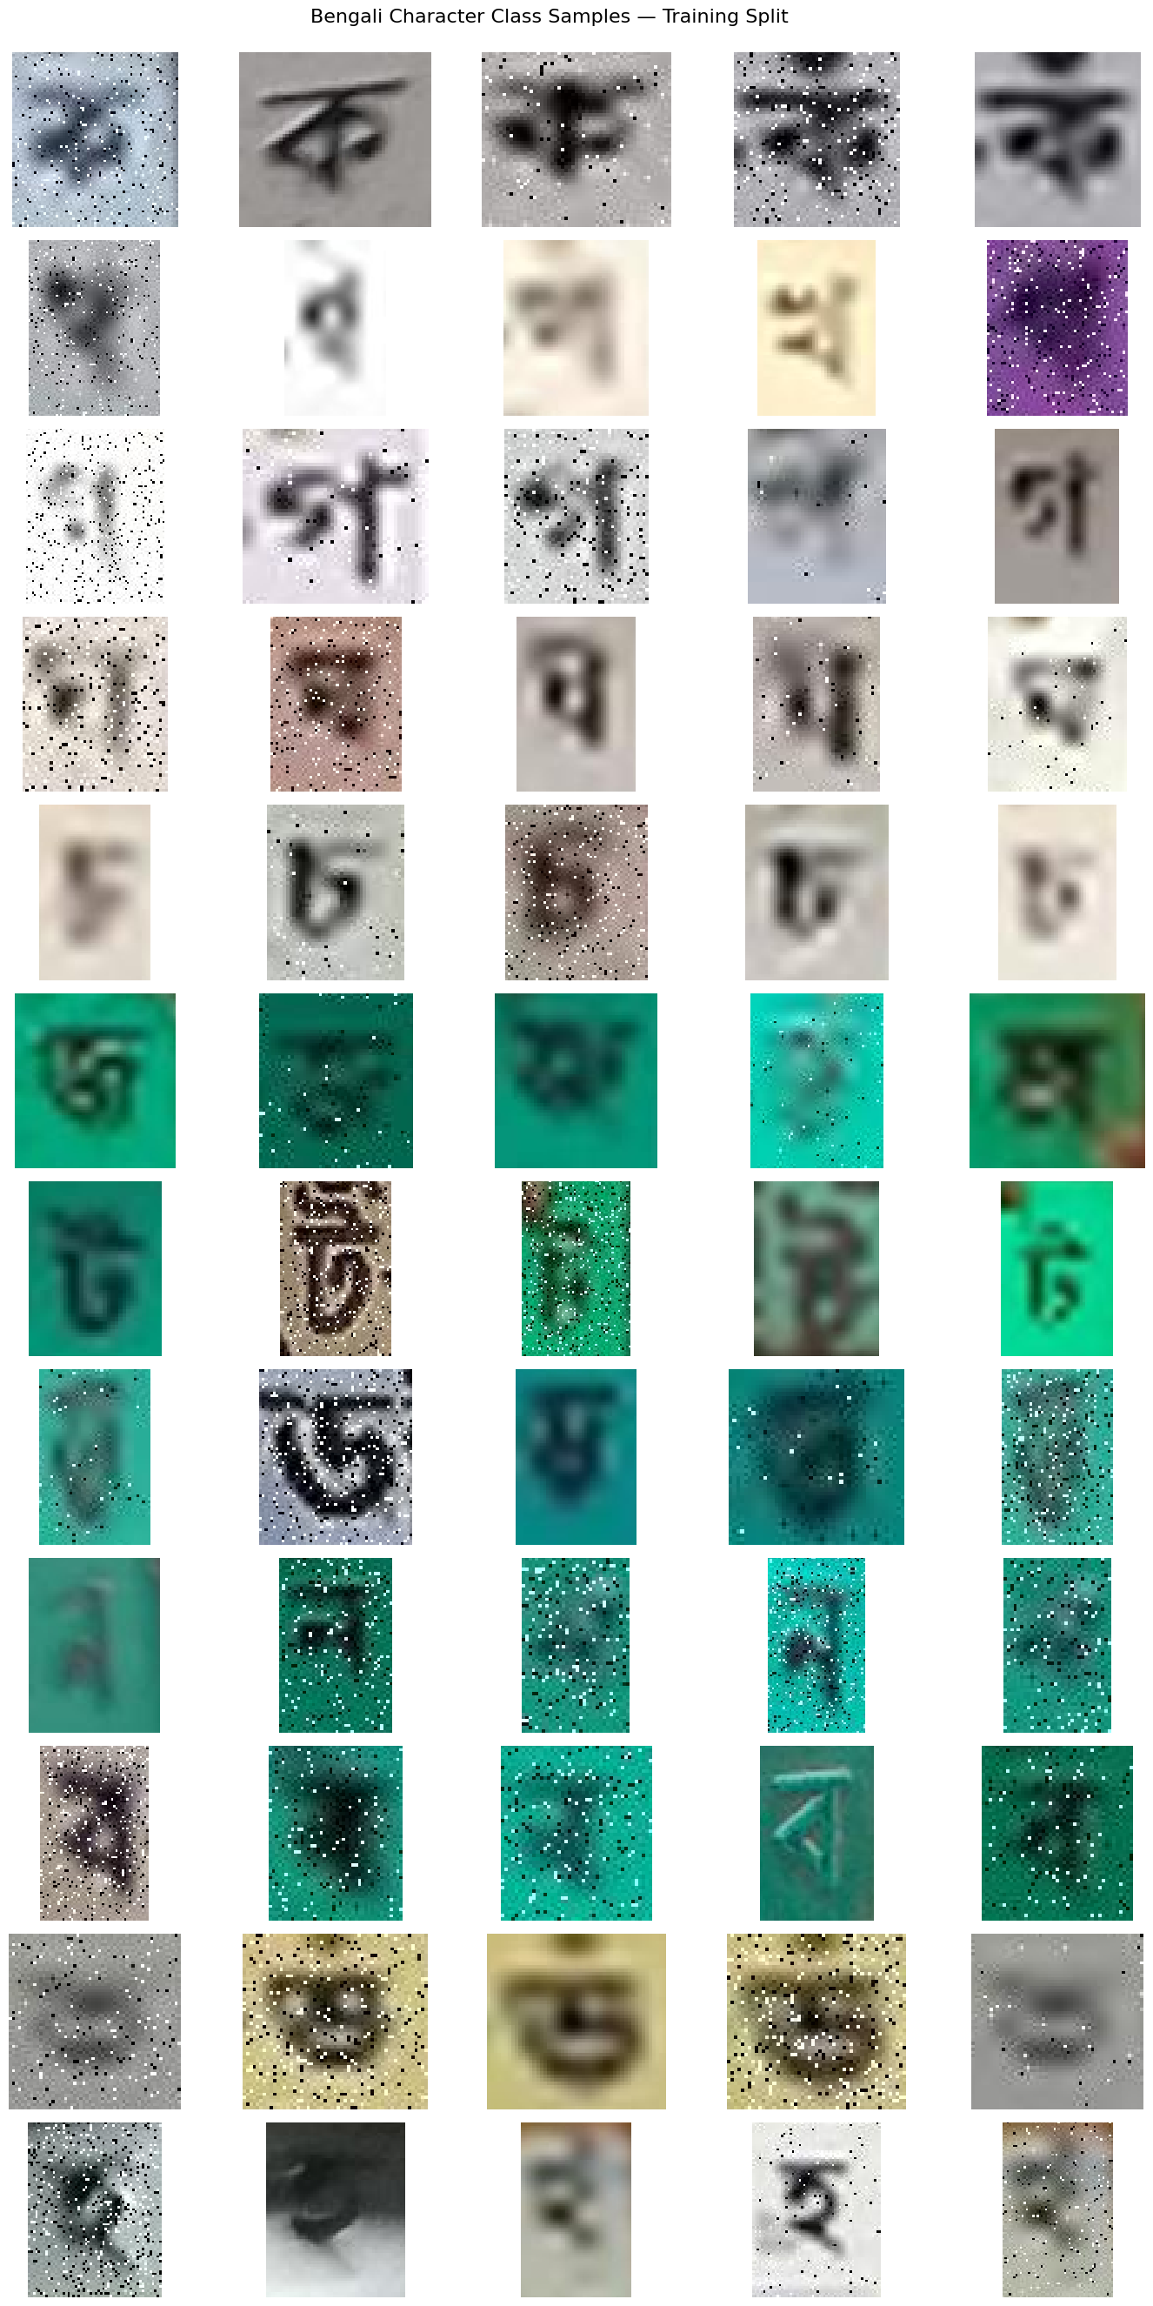
Figure 5: Bengali Character Class Samples

2.2 Synthetic-faded data
Every clean image has one faded copy with identical labels, giving 3,480 + 363 + 218 = 4,061 faded images. For the Family 2 fading models, the 3,480 clean and 3,480 faded training images are combined (6,960); their validation and test sets are the clean ones. A faded image is made from an image of the same split, so fading itself creates no overlap between splits.

2.3 Real faded plates
The real set has 67 cropped plates (Figure 6) were collected from various sources [34], [35], [36], [37]. Sixty-four carry manually transcribed ground truth (for example, Dhaka metro-ga 22-4218); three plates were too unclear to transcribe and are excluded from scoring.

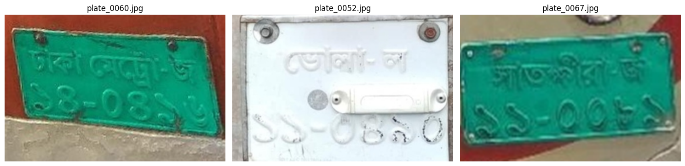

Figure 6: Real Faded License Plate
Table 2 Summary of the real-faded evaluation set.
Attribute | Value
Total images | 67
Images with usable ground-truth transcriptions | 64
Images without usable ground-truth transcriptions | 3

3. Synthetic Fading
A single function, fade_once, changes pixels only, so labels stay valid. The same code is used offline and online. The complete procedure is called BanglaPlateFade in this thesis. It is used offline to create faded copies of training images (Family 2) and online as a training-time augmentation applied with probability 0.60 (Model B).
Operation | Setting
Ink mask | Otsu threshold clipped to 40–150, then 3×3 opening and closing
Background colour | Median of non-ink pixels brighter than 120
Per-character fade | Strength drawn uniformly from 0.80–0.97 for each connected ink component (0.80–1.0 if under 30 pixels)
Spatial variation | Smoothed random field with values 0.75–1.0
Rust | Blotches, coverage 0.12, colour (155, 100, 65), strongest near plate edges
Noise | Gaussian, σ = 4
Scratches | 0–5 grey lines, alpha 30–90
Blur and photometric | Gaussian blur radius 0–1.0; brightness 0.85–1.15; contrast 0.80–1.10
Table 3 Operations in fade_once.
The settings were chosen by visual inspection and were not fitted to the real faded photographs.
A general fading transformation can be as expressed in Eq. (1)

$I_{f}\left(x,y\right)=(1-w). I\left(x,y\right)+w. B\left(x,y\right)$ (1)
where:
$w$ = ink mask × fade strength × spatial field

Here:
$I(x, y)$ represents the original image pixel;
$I_{f}\left(x,y\right)$represents the faded pixel;
$α$ controls the contribution of the original image;
$B(x, y)$ represents the blending layer;
$w$ controls the overall blending weight, determined by the product of the ink mask, fade strength, and spatial field.

4. Severity levels
Fading severity levels used in the graded-fading test. Each level is generated from the 218 held-out test images with the fade_once function by changing the fade strength, rust, noise, and blur settings.
Table 4 Fading Severity Levels Used in the Graded-Fading Test
Level | Fade strength | Rust | Noise σ | Max blur radius
Mild | 0.35–0.55 | 0.04 | 2.0 | 0.35
Moderate | 0.60–0.80 | 0.08 | 3.0 | 0.65
Strong | 0.80–0.97 | 0.12 | 4.0 | 1.0

The strong level matches the settings used to generate the training faded images.
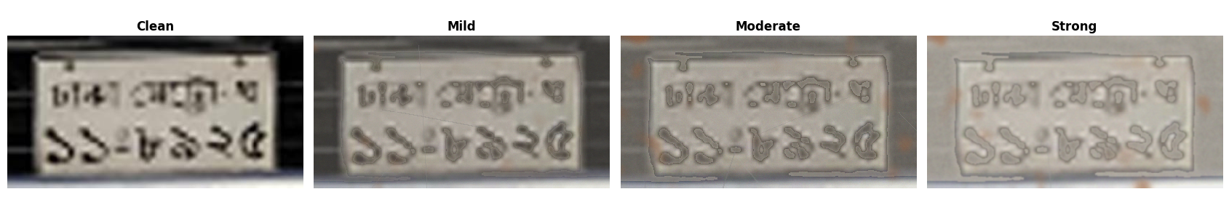
Figure 7: One clean training image and three faded versions

5. Models and Training
Table 5 Trained models. Best epoch = highest validation fitness (0.1 × mAP@0.50 + 0.9 × mAP@0.50:0.95) on the clean validation split.
Model | Architecture | Training data | Batch | Epochs run (best) | Time (h)
Model A | YOLOv8n | Clean (3,480) | 16 | 50 (10) | 0.34
Model B | YOLOv8n | Clean + online fading | 16 | 50 | 2.53
YOLOv5s_clean | YOLOv5su | Clean (3,480) | 8 | 33 (23) | 0.41
YOLOv5s_clean_fading | YOLOv5su | Clean + faded (6,960) | 8 | 24 (14) | 0.57
YOLO11n_clean | YOLO11n | Clean (3,480) | 16 | 39 (29) | 0.32
YOLO11n_clean_fading | YOLO11n | Clean + faded (6,960) | 16 | 24 (14) | 0.36

All models start from COCO-pretrained Ultralytics weights and were trained at 640 px, seed 42, with mixed precision and at most 50 epochs. Ultralytics’ automatic optimizer choice selected AdamW with learning rate 0.000323. Family 2 used patience 10 and default augmentation, including horizontal flip 0.5; Family 1 used flip-free settings (mosaic 0.5, scale 0.30, translation 0.05, rotation ±2°).

Software: Kaggle - Ultralytics 8.4.174–8.4.175, PyTorch 2.11.0 (CUDA 12.8), Python 3.13, one Tesla T4 GPU.

6. Evaluation Sets and Decoding
Table 6 Evaluation sets.
Box | Text
Clean test set (218 images) | Precision, recall, mAP@0.50, mAP@0.50:0.95; sequence accuracy, TER, digit CER
Synthetic-faded test set (218 images) | Detection metrics; Models A and B at mild, moderate, and strong fading
Real faded test set (64 labeled of 67) | Strict exact accuracy; digit CER
Comparison and analysis | Paired statistical tests (McNemar, bootstrap); Model A vs Model B; clean vs fading pairs

Detection metrics. Precision, recall, mAP@0.50, and mAP@0.50:0.95 come from the Ultralytics validator on the test split.

Decoding
Detections with confidence ≥ 0.25 were kept. Family 1 kept digit classes, retained the six most confident, and sorted left to right. Family 2 sorted digits left to right (raw) or first applied class-agnostic suppression at IoU ≥ 0.90 (deduplicated). The clean-test decoder split two-line plates into rows.

Precision
Precision measures the proportion of predicted positive detections that are correct as defined in Eq.2
$P=\frac{TP}{TP+FP}$ (2)
where $TP$ represents true-positive detections and $FP$ represents false-positive detections.
Higher precision indicates fewer false-positive predictions relative to the total number of predicted detections.
Recall
Recall measures the proportion of ground-truth objects successfully detected as defined in Eq.3
$R=\frac{TP}{TP+FN}$ (3)
where $FN$ represents false-negative detections.

Higher recall indicates that a larger proportion of the annotated objects has been detected. Precision and recall provide complementary information about detection performance.
Intersection over Union
Intersection over Union $IoU$ measures the overlap between a predicted bounding box and its corresponding ground-truth bounding box as expressed in Eq.4
$IoU=\frac{|Bp∩Bg|}{|Bp∪Bg|}$ (4)

where $Bp$ is the predicted box and $Bg$ is the ground-truth box.
A predicted box matches a ground-truth box of the same class when their IoU is at least 0.50; mAP@0.50:0.95 averages thresholds from 0.50 to 0.95 in steps of 0.05

Full-Sequence Exact Accuracy
For real-faded recognition, full-sequence exact accuracy measures the proportion of labeled plates for which the complete predicted string matches the ground truth after predefined normalization. Which defined in Eq.5

$A_{exact}=\frac{N_{exact}}{N_{labeled}}×100$ (5)

where $N_{exact}$ is the number of exactly correct predicted sequences and $N_{labeled}$ is the total number of labeled test images.
In the strict evaluation, the denominator is 64 labeled images. Missing or incomplete predictions count as incorrect. This avoids inflating the score by excluding difficult images that do not produce a usable prediction.

Character Error Rate
Character Error Rate (CER) measures the minimum number of character-level substitutions, deletions, and insertions required to transform a predicted sequence into its ground-truth sequence, divided by the number of characters in the ground truth as defined in Eq.6
$CER=\frac{S+D+I}{N}$ (6)
where (S), (D), and (I) denote substitutions, deletions, and insertions, respectively, and (N) is the number of characters in the ground-truth sequence.
For real faded plates, CER is computed per plate on the six-digit registration number: the Levenshtein distance between the predicted and true digit strings divided by 6. A plate with no predicted digits has a CER of 1.0. The reported value is the mean of these per-plate ratios, not the total number of errors divided by the total number of digits. On the clean test set, the digit CER is computed in the same way on the digit tokens of each image’s ordered sequence and averaged over the 218 images.
The token error rate (TER) applies the same idea to the full sequence of class tokens, which includes digits, Bengali series letters, and word classes such as metro and dhaka. For each clean test image it is the token-level edit distance between the predicted and ground-truth sequences divided by the number of ground-truth tokens, averaged over images. Full-sequence exact accuracy requires every token to match; digit-sequence exact accuracy requires every digit to match.
A lower CER indicates better character-level agreement. CER can exceed 1 when the number of edit operations exceeds the ground-truth sequence length. The implementation should explicitly define how missing predictions and empty strings are handled.
Table 7 Evaluation metrics and their purposes
Metric | Evaluation stage | Purpose | Preferred direction
Precision | Object detection | Measure correctness of predicted detections | Higher
Recall | Object detection | Measure recovery of ground-truth objects | Higher
mAP50 | Object detection | Measure detection quality at IoU 0.50 | Higher
mAP50–95 | Object detection | Measure detection quality across IoU thresholds | Higher
Full-sequence exact accuracy | Real-faded recognition | Measure completely correct plate strings | Higher
CER | Real-faded recognition | Measure character-level transcription errors | Lower
TER | Clean-test sequence recognition | Measure token-level transcription errors | Lower

Statistics:
Paired comparisons used an exact two-sided McNemar test (α = 0.05) and a paired percentile bootstrap (20,000 image resamples, seed 42). No multiple-comparison correction was applied.

Ⅳ. Results and Discussion

This chapter presents and discusses the experimental results of the proposed Bangladeshi license plate detection and recognition study. The experiments investigate whether training a YOLO-based detector with synthetically faded license plate images improves its robustness compared with a model trained using clean images.

The evaluation considers three aspects: object detection performance, license plate sequence recognition performance, and recognition performance on a separate collection of real faded license plate images. Detection performance is assessed using precision, recall, mean Average Precision at an Intersection over Union threshold of 0.50 (mAP@0.50), and mean Average Precision across IoU thresholds from 0.50 to 0.95 (mAP@0.50:0.95). Recognition performance is assessed using complete-sequence accuracy and character-level error measures.

The section first reports the controlled validation results and clean-test performance. It then examines performance on real faded images and discusses the implications, limitations, and reliability of the findings.

Experimental Evaluation Overview
Two experiment families were evaluated. Family 1 consists of two YOLOv8n detectors: Model A (baseline), trained on clean images only, and Model B (synthetic fading), trained with online synthetic fading (p = 0.60). Family 2 consists of YOLOv5su and YOLO11n, each trained either on clean images only (_clean) or on clean plus synthetically faded copies (_clean_fading). Within each family, the comparison isolates the effect of fading in the training data. The two families are reported separately, because their architectures, augmentation settings, and real-plate decoders differ.
The purpose of this comparison was to determine whether exposure to faded examples during training improves detection and recognition under challenging visual conditions.
The experiments were evaluated on clean test images, synthetic-faded test images, and a separate collection of real faded license plate images. These evaluation sets serve different purposes. The clean test set measures performance on the original image condition, the synthetic-faded test set measures robustness to generated degradation, and the real-faded set provides an additional test of performance on naturally occurring fading.

Object Detection Results

2.1 Validation performance of Model B.
On the 363 validation images, Model B obtained a precision of 94.89%, recall of 89.11%, mAP@0.50 of 94.64%, and mAP@0.50:0.95 of 70.74%. These values were used to select its best checkpoint. A supplementary fine-tuning experiment is reported in Section 4.5.

2.2 Comparison on the Clean Test Set
The main two-model clean-test experiment produced the results shown in Table 8.
Table 8 Object detection performance on the clean test set
Model | Precision (%) | Recall (%) | mAP@0.50 (%) | mAP@0.50:0.95 (%)
Model A – Baseline | 94.76 | 89.18 | 94.13 | 70.49
Model B – Synthetic Fading | 94.65 | 92.49 | 95.70 | 71.73
Difference (B − A) | −0.11 | +3.30 | +1.57 | +1.24

On the clean test set, Model B achieved a recall of 92.49%, compared with 89.18% for Model A. This represents an increase of approximately 3.30 percentage points. Model B also improved mAP@0.50 by approximately 1.57 percentage points and mAP@0.50:0.95 by approximately 1.24 percentage points.

Precision was slightly lower for Model B, decreasing from 94.76% to 94.65%. The difference was only about 0.11 percentage points. Thus, the synthetic-fading-trained model showed higher recall and mean Average Precision while maintaining a similar precision level.

The increase in recall indicates that Model B detected a greater proportion of the annotated objects under the evaluated conditions. The improvement in mAP suggests that the model also achieved better overall detection performance across the evaluated confidence and localization criteria.

Importantly, these results do not indicate that synthetic fading improved every metric. Instead, the results show a trade-off in which recall and mAP improved slightly while precision remained nearly unchanged.

2.3 Interpretation of Detection Performance
The clean-test results suggest that including synthetic fading during training did not substantially damage performance on clean images. This is an important consideration because a robustness-oriented training strategy should ideally improve performance under degraded conditions without causing a large loss in normal conditions.
Model B's higher recall is consistent with the possibility that exposure to faded examples helps the detector learn features that remain useful when plate appearance varies. However, this experiment alone does not establish which visual features were learned or prove that synthetic fading is the sole cause of the improvement. Such claims would require controlled repeated experiments or additional ablation studies.
The results should therefore be interpreted as evidence of an observed performance difference between the two recorded models, rather than proof of a general improvement across all datasets or operating environments.

Table 9 Detection performance on the synthetic-faded test set
Model | Condition | Precision | Recall | mAP@0.50 | mAP@0.50:0.95
YOLOv5s_clean | Clean | 0.937 | 0.945 | 0.958 | 0.716
YOLOv5s_clean | Synthetic-faded | 0.759 | 0.657 | 0.706 | 0.502
YOLOv5s_clean_fading | Clean | 0.934 | 0.940 | 0.967 | 0.727
YOLOv5s_clean_fading | Synthetic-faded | 0.918 | 0.948 | 0.961 | 0.724
YOLO11n_clean | Clean | 0.962 | 0.902 | 0.949 | 0.716
YOLO11n_clean | Synthetic-faded | 0.742 | 0.590 | 0.656 | 0.467
YOLO11n_clean_fading | Clean | 0.916 | 0.896 | 0.938 | 0.706
YOLO11n_clean_fading | Synthetic-faded | 0.874 | 0.913 | 0.940 | 0.702

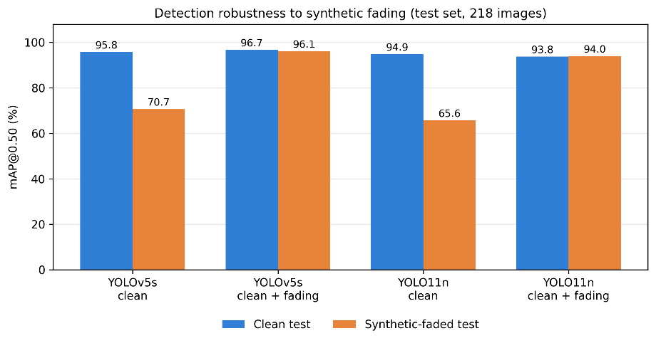
Figure 8: mAP@0.50 on the clean and synthetic-faded test sets for the four models.

  - Clean-trained models collapse. From clean to faded images, mAP@0.50 falls by 0.252 (YOLOv5s) and 0.292 (YOLO11n), and recall by 0.288 and 0.312. Most of the loss is missed characters, since precision falls less than recall.
  - Fading-trained models hold. Their mAP@0.50 changes by −0.006 (YOLOv5s) and +0.002 (YOLO11n), and mAP@0.50:0.95 by −0.003 and −0.004. On faded images they beat their clean partners by 0.255 and 0.284 mAP@0.50.
  - No clear cost on clean images. Fading training changes clean mAP@0.50 by +0.009 (YOLOv5s) and −0.011 (YOLO11n). With one run per model, differences of about 0.01 are not interpretable.

The faded test images come from the same generator as the training fade, so Table 10 shows robustness to this specific degradation, not to fading in general.

Models A and B

3.1 Graded synthetic fading
To isolate the effect of the fading augmentation, both models were evaluated at the three severity levels defined in Table 4 on the same 218 clean test images and on corresponding synthetic variants at mild, moderate, and strong fading severities. The degraded images were generated from held-out test images for evaluation; they were not added to the training data for these test runs. The comparison therefore measures response to the particular synthetic degradation procedure used in this study rather than to all possible real-world conditions.

Table 10 Models A and B on the 218 test images at four fading levels.
Condition | A mAP@50 | B mAP@50 | Δ mAP@50 (pp) | A Recall | B Recall | Δ Recall (pp)
Clean | 94.13 | 95.70 | +1.57 | 89.18 | 92.49 | +3.30
Mild fading | 93.74 | 95.97 | +2.22 | 88.46 | 92.97 | +4.51
Moderate fading | 90.90 | 95.26 | +4.35 | 82.11 | 93.29 | +11.18
Strong fading | 78.39 | 94.84 | +16.44 | 67.85 | 90.03 | +22.18

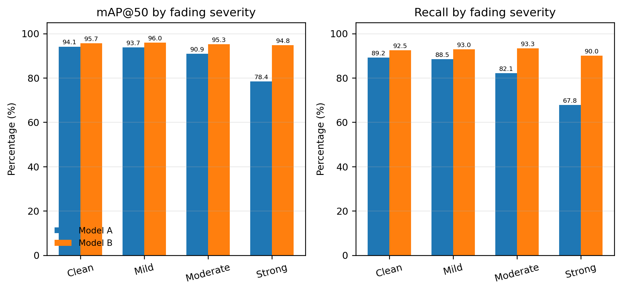
Figure 9: mAP@50 and recall under increasing synthetic fading severity.

On clean images, Model B exceeded Model A by 1.57 points in mAP@50. The gap increased to 2.22 points under mild fading and 4.35 points under moderate fading. Under strong fading, Model A mAP@50 fell to 78.39%, while Model B retained 94.84%, a difference of 16.44 percentage points. Recall showed a similar pattern: at strong severity it was 67.85% for Model A and 90.03% for Model B, a gain of 22.18 points. mAP@50–95 at strong severity was 53.98% for Model A and 69.41% for Model B.
The sharp widening of the performance gap under strong degradation is the strongest evidence that synthetic fading augmentation improved robustness to the fading process represented in the experiments. Model B also had higher mAP@50–95 in the clean, mild, moderate, and strong conditions. Precision under strong fading was 80.90% for Model A and 94.84% for Model B. These observations are consistent with the augmentation helping the model retain features under weakened contrast and simulated surface wear. They do not establish robustness to fog, rain, night lighting, or other degradations that were not separately tested.

3.2 Clean-test sequence recognition
Table 11 Sequence recognition on the 218 clean test images, with paired statistics for B − A.
Metric | Model A % | Model B % | Difference (95% CI) | A-only / B-only correct | McNemar p
Full-sequence exact accuracy (%) | 72.48 | 78.44 | +5.96 pp [1.83, 10.09] | 5 / 18 | 0.0106
Digit-sequence exact accuracy (%) | 88.07 | 89.91 | +1.83 pp [−1.38, 5.05] | 4 / 8 | 0.388
Token error rate (%) | 5.31 | 3.70 | −1.62 pp [−2.69, −0.67] | n/a | n/a
Digit CER (%) | 3.28 | 2.86 | −0.42 pp [−1.07, 0.23] | n/a | n/a
On clean images, Model B's advantage is significant for whole-sequence accuracy and token error rate, which include the letters and word classes, but not for the digits alone.
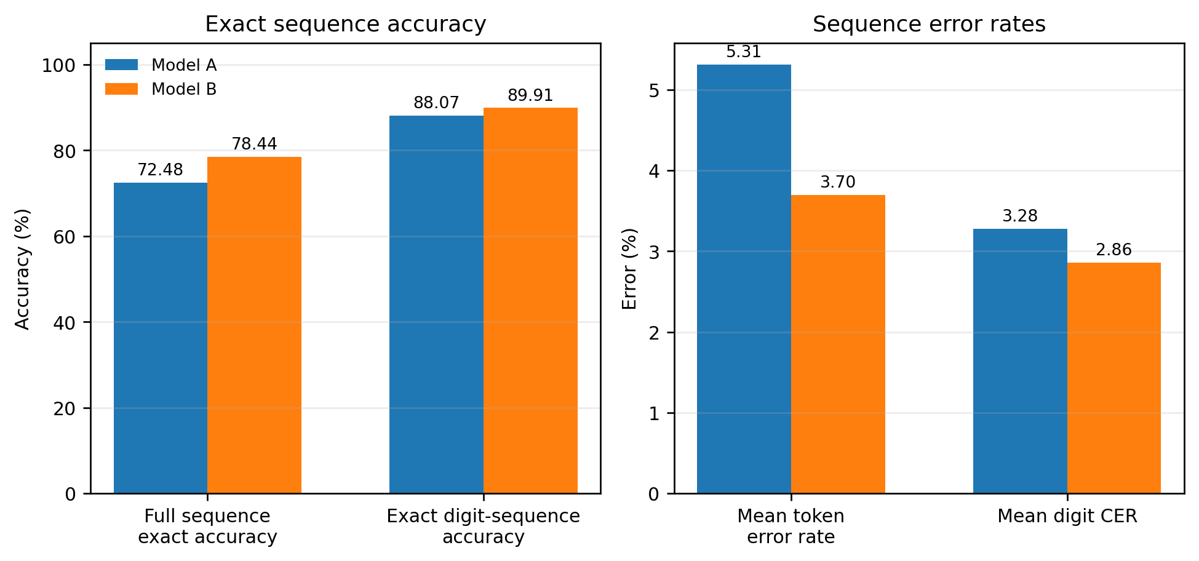
Figure 10: Exact sequence accuracies and average sequence error rates.

Real Faded Plates

4.1 Models A and B
Table 12 Registration-number recognition on the 64 labeled real faded plates.
Metric | Model A | Model B
Complete six-digit predictions | 54 | 55
Exact matches | 30 | 43
Strict exact accuracy | 46.88% | 67.19%
Conditional exact accuracy | 55.56% | 78.18%
Mean digit CER | 18.49% | 8.07%
Model B reads 13 more plates exactly (+20.3 percentage points) and cuts the mean digit CER by 10.4 points, a 56% relative reduction. Of the 15 plates on which the models differ, 14 favor Model B and one (plate_0066) favors Model A; 29 plates are correct for both and 20 for neither. The exact McNemar p-value is 0.000977, and a paired bootstrap of the pair counts gives a 95% interval of [9.4, 31.3] points for the accuracy gain. Typical Model A errors are a substituted or dropped digit, for example 111435 for 111335 (plate_0007) or 1658 for 130558 (plate_0015), both read correctly by Model B.

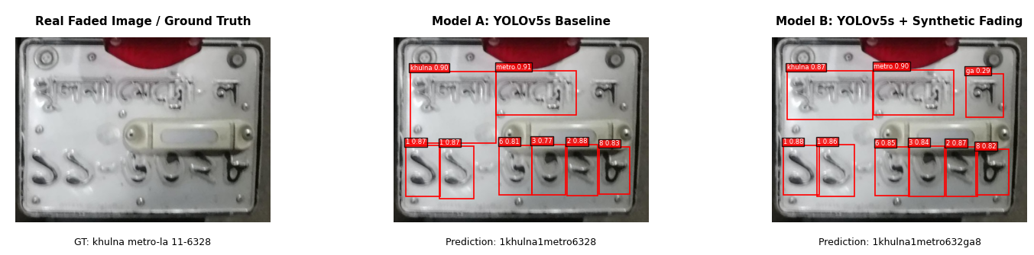
Figure 11: Real faded plates with ground truth and the predictions of Models A and B.

4.2 Family 2: raw and deduplicated decoding
Table 13 Real faded plates, Family 2 (confidence 0.25).
Model | Raw exact | Raw six-digit predictions | Raw mean CER | Deduplicated exact
YOLOv5s_clean | 29 (45.3%) | 42 | 20.6% | 29 (45.3%)
YOLOv5s_clean_fading | 38 (59.4%) | 49 | 13.3% | 40 (62.5%)
YOLO11n_clean | 28 (43.8%) | 38 | 25.0% | 31 (48.4%)
YOLO11n_clean_fading | 32 (50.0%) | 43 | 16.4% | 37 (57.8%)

Fading training raises raw exact matches by 9 for YOLOv5s and 4 for YOLO11n, and lowers raw CER by 7.3 and 8.6 points. Table 15 shows which of these gains are statistically supported.
Table 14 Paired comparison of raw predictions, fading-trained versus clean partner (64 plates).

Pair | Clean-only / fading-only correct | McNemar p | Exact accuracy difference (95% CI) | CER difference (95% CI)
YOLOv5s | 2 / 11 | 0.0225 | +14.1 pp [3.1, 25.0] | −7.3 pp [−12.5, −2.3]
YOLO11n | 5 / 9 | 0.424 | +6.3 pp [−4.7, 17.2] | −8.6 pp [−14.1, −3.7]
The YOLOv5s exact-match gain is significant at the 0.05 level; the YOLO11n gain is not, although its CER reduction has an interval that excludes zero.
Duplicate suppression raised exact matches for every model except YOLOv5s_clean: by 2 plates (YOLOv5s_clean_fading), 3 (YOLO11n_clean), and 5 (YOLO11n_clean_fading), and worsened none. The cause is visible in the YOLOv5s_clean_fading detections: 12 plates had more than six digit detections, and 15 box pairs overlapped with IoU ≥ 0.80, usually with different digit labels (for example a 5 and a 0 at IoU 0.99). Class-agnostic suppression cannot remove such pairs, which is why suppression ignores the class. For plate_0037 it turns 1108432 into the correct 110843. Because duplicate suppression (IoU ≥ 0.90) and confidence threshold parameters were evaluated directly on the 64 real faded test plates, these post-processing evaluations are reported strictly as exploratory sensitivity analyses.

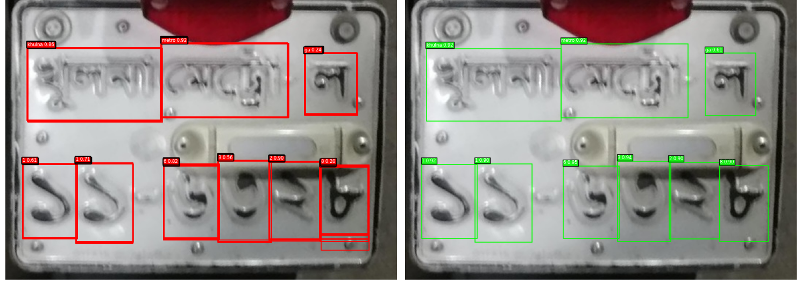
Figure 12: Duplicate digit boxes on a real plate before and after suppression.
Duplicate digit boxes on a real plate before and after suppression.

4.3 Confidence threshold (YOLOv5s_clean_fading, raw decoding)
Table 15 Effect of the confidence threshold on the 64 real faded plates.
Threshold | Exact matches | Exact accuracy | Mean CER | Six-digit predictions
0.10 | 38 | 59.38% | 13.28% | 49 (76.56%)
0.20 | 38 | 59.38% | 13.28% | 49 (76.56%)
0.25 | 38 | 59.38% | 13.28% | 49 (76.56%)
0.30 | 36 | 56.25% | 13.02% | 50 (78.12%)
0.40 | 34 | 53.12% | 13.80% | 46 (71.88%)
0.50 | 34 | 53.12% | 15.10% | 40 (62.50%)
Exact accuracy is flat up to 0.25 and then falls, while the lowest CER (0.30) and the highest six-digit rate (0.30) occur at a different threshold. The column "six-digit predictions" counts plates with exactly six digits; it is not an accuracy. No threshold was tuned on separate validation data.

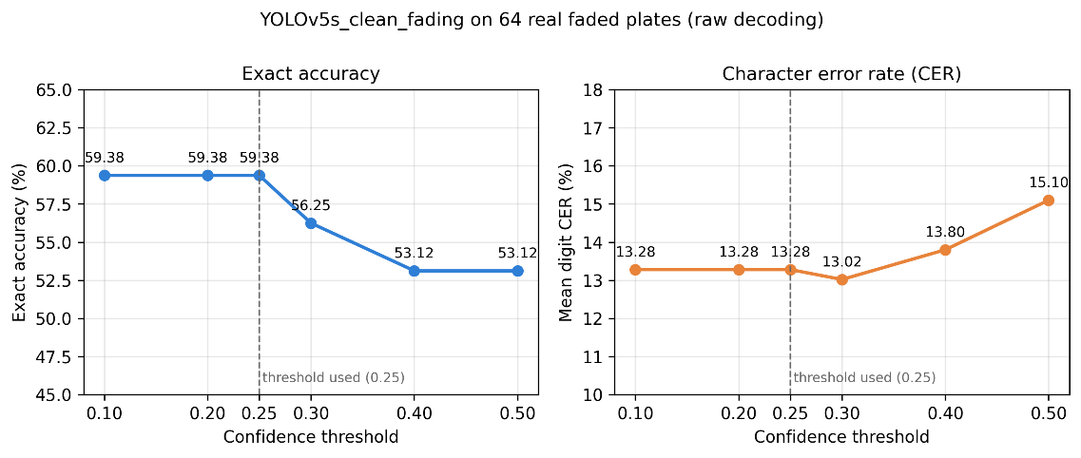
Figure 13: Exact accuracy and CER against confidence threshold.

4.4 Class-wise performance and limitations of rare-class estimates
Overall mAP can conceal differences between individual classes. The class-wise test results show that Model B improved F1 for some character classes, including ka, na, kha, and ta, while it regressed on da and jashore. Selected results are presented in Table 16. The class support column is important: the clean test set contains only two ka instances, two na instances, five da instances, and nine jashore instances. Class-wise estimates for these categories are therefore highly sensitive to a small number of predictions and should be interpreted as diagnostic evidence rather than definitive population-level comparisons.

Table 16 Selected class-wise test metrics.

Class | Test instances | F1 A (%) | F1 B (%) | Δ F1 (pp) | mAP@50 A (%) | mAP@50 B (%)
ka | 2 | 64.74 | 83.86 | +19.12 | 51.14 | 99.50
na | 2 | 60.77 | 88.75 | +27.98 | 82.83 | 99.50
da | 5 | 83.31 | 63.67 | -19.64 | 96.17 | 69.50
ca | 9 | 78.35 | 81.76 | +3.41 | 87.79 | 87.90
jashore | 9 | 98.74 | 91.31 | -7.43 | 99.50 | 97.50
kha | 10 | 75.05 | 88.78 | +13.73 | 86.07 | 84.43
gha | 16 | 79.25 | 83.55 | +4.30 | 89.73 | 89.80
ta | 16 | 92.14 | 95.90 | +3.76 | 94.38 | 98.03
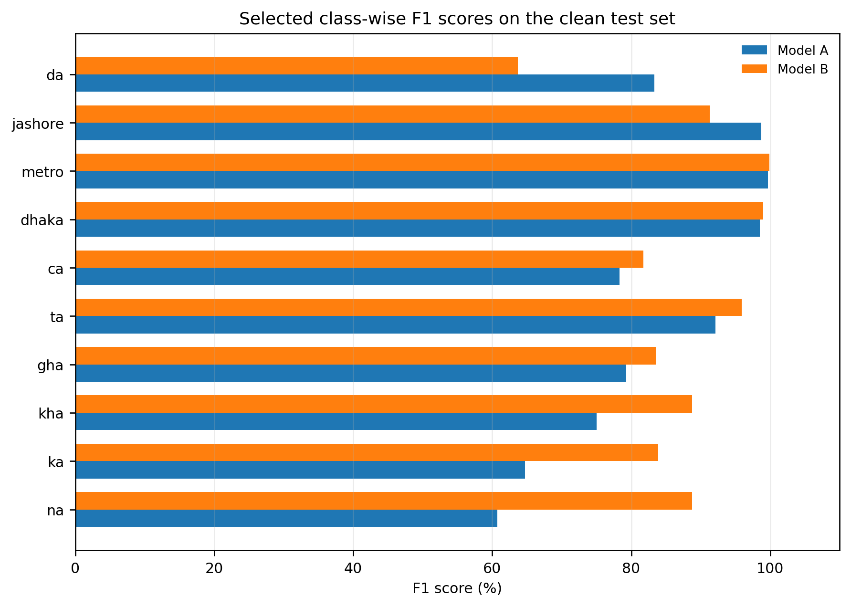
Figure 14: F1 comparison for selected character and word classes.

4.5 Exploratory targeted fine-tuning
The class-wise analysis Table 16 showed that Model B scored lower F1 than Model A on the rare classes da (5 test instances) and jashore (9). Because da has only 48 training instances, a targeted fine-tuning run was tried for this class; jashore was not targeted. The choice was informed by the test-set class-wise results, so the experiment is exploratory, and its outcome is judged on the validation set only.
The 48 training images containing da were each copied twice with random appearance changes, adding 96 images to give 3,576 training images. Model B was fine-tuned from its best checkpoint for up to 25 epochs (AdamW, learning rate 0.0003, batch 16, early stopping with patience 8), with mosaic, mixup, flips, rotation, and translation disabled, scale 0.10, and mild color jitter. Training stopped after 12 epochs; epoch 4 gave the best validation score.
Here Table 17 compares the original and fine-tuned checkpoints on the 363 validation images.
Table 17 Controlled validation comparison for the exploratory fine-tuned checkpoint
Validation metric | Original Model B (%) | Fine-tuned Model B (%) | Δ (pp)
Precision | 94.89 | 94.63 | −0.26
Recall | 89.11 | 91.02 | +1.91
mAP@50 | 94.64 | 95.29 | +0.65
mAP@50–95 | 70.74 | 70.63 | −0.11
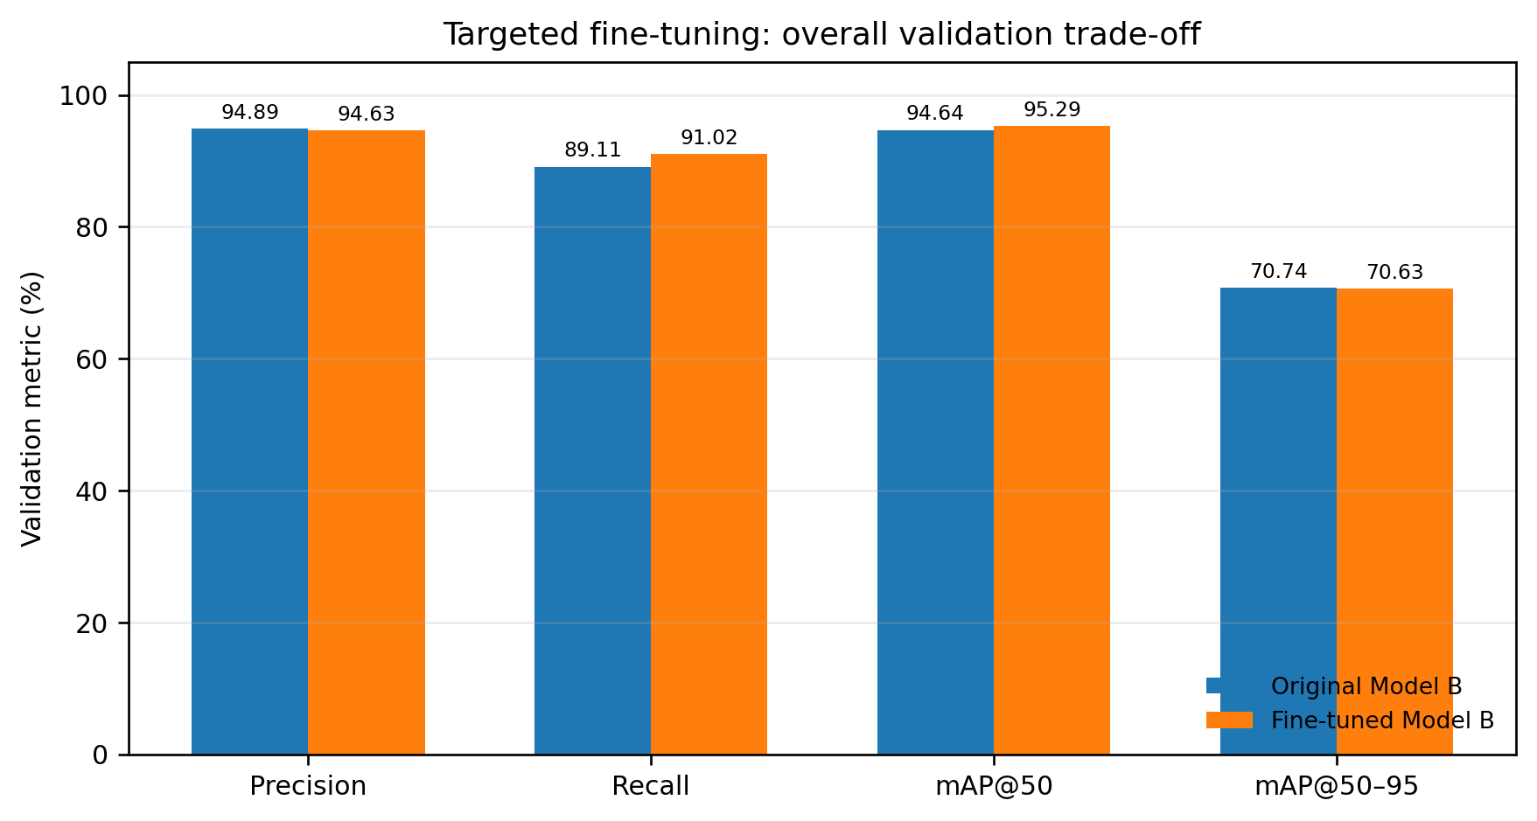
Figure 15: Overall validation trade-off after targeted fine-tuning.
Overall recall rose by 1.91 points and mAP@0.50 by 0.65 points, whereas precision fell by 0.26 points and mAP@0.50:0.95 by 0.11 points. For the target class da, mAP@0.50 rose from 68.25% to 74.50%, but F1 fell from 69.37% to 58.39% because precision dropped from 64.53% to 47.80% while recall stayed at 75.00% (3 of 4 validation instances). For jashore, F1 fell from 88.08% to 85.99%.

The validation set holds only four da instances, so one or two extra false positives are enough to produce these changes. The checkpoint was also selected on the same validation split used for the comparison, so the overall gains are probably optimistic. The fine-tuned model was not used for any test-set or real-plate result, and the targeted objective was not met. The experiment is therefore reported as a negative, exploratory result: rare-class improvement likely needs more real examples, not only augmented copies of the few that exist.

Summary of Results
  - Synthetic fading removes about a quarter of the clean-trained detectors' mAP@0.50; fading-trained models keep it (Tables 10, 11).
  - On clean images, fading training did not clearly cost accuracy, and for Model B it significantly improved whole-sequence accuracy (Table 12).
  - On 64 real faded plates, fading training raised exact matches in all three comparisons: Model B over Model A (+20.3 points, p = 0.001) and YOLOv5s (+14.1 points, p = 0.02) with statistical support, and YOLO11n (+6.3 points) without it (Tables 13–15).
  - Duplicate suppression and the confidence threshold change real-plate accuracy by several points, so they are part of the system and must be reported with it (Tables 14, 16).

Ⅴ. Conclusion

Introduction
This chapter presents the conclusions of the research on improving the robustness of Bangladeshi vehicle license plate detection and character recognition under degraded visual conditions. The study investigated the effectiveness of synthetic fading augmentation in improving the performance of a lightweight YOLO-based character detection model. The research focused on comparing a baseline model trained without the proposed synthetic fading augmentation against an augmented model trained with the BanglaPlateFade transformation.
The experimental evaluation was conducted using clean test images and a separate collection of real faded license plate images. The analysis considered object detection performance, complete license plate sequence accuracy, character-level error rate, and qualitative detection results. The study also examined the differences between clean, synthetically degraded, and real faded images to understand the limitations of synthetic degradation as a representation of real-world image deterioration.
This chapter summarizes the principal findings, discusses the research contributions, identifies the limitations of the current work, and presents directions for future research.

Summary of the Research
The primary objective of this research was to investigate whether synthetic fading augmentation could improve the detection and recognition of Bangladeshi license plate characters under degraded visual conditions.
The research used a lightweight YOLO-based character detection approach. Two principal models were evaluated:
- Model A – Baseline Model: Trained without the custom synthetic fading augmentation.
- Model B – Synthetic Fading Model: Trained using the BanglaPlateFade augmentation with an augmentation probability of 0.60.
The main dataset contained 4,061 images distributed across 27 classes, with 3,480 training images, 363 validation images, and 218 test images. Synthetic fading was incorporated into the training process to expose the augmented model to additional variations in plate appearance.
The evaluation was conducted at two levels. First, the models were compared using object detection metrics, including precision, recall, mean Average Precision at an intersection-over-union threshold of 0.50 (mAP@0.50), and mAP@0.50:0.95. Second, character recognition performance was evaluated using complete sequence accuracy and Character Error Rate (CER).
A separate real-faded image collection was used to investigate how the models performed on degraded plates outside the clean test evaluation. This additional evaluation provided evidence about the practical challenges of recognizing faded characters, although the collection did not contain verified bounding-box annotations for all images.

Answers to the Research Questions
RQ1. Clean-trained YOLOv5s and YOLO11n lost 0.252 and 0.292 mAP@0.50; Model A lost 0.157 under strong fading.
RQ2. Yes. Fading-trained models lost at most 0.006 and showed no clear change on clean images (+0.009 and −0.011), though the test fading uses the training generator.
RQ3. Partly. Exact matches rose in all three comparisons (+20.3, +14.1, and +6.3 points), on a small real set.
RQ4. Firmly only for Model B on real plates (p = 0.001); the YOLOv5s (p = 0.0225) and clean-test sequence (p = 0.0106) results are suggestive after correction, and YOLO11n is not significant.
RQ5. Duplicate suppression added 2 to 5 correct plates for three of four models, and raising the threshold from 0.25 to 0.50 lowered exact accuracy from 59.38% to 53.12%.

4. Summary of Major Findings

4.1 Object Detection Performance
The object detection results demonstrated that the synthetic fading model achieved better overall performance than the baseline model on the clean test set.
The baseline model achieved a precision of 94.76%, recall of 89.18%, mAP@0.50 of 94.13%, and mAP@0.50:0.95 of 70.49%. In comparison, the synthetic fading model achieved a precision of 94.65%, recall of 92.49%, mAP@0.50 of 95.70%, and mAP@0.50:0.95 of 71.73%.
The augmented model therefore achieved higher recall and higher values for both reported mAP metrics, while precision remained approximately the same.
The recall improvement indicates that the augmented model detected a larger proportion of the annotated characters. The increase in mAP suggests that the model achieved better overall detection performance across the evaluated confidence and localization criteria.
These findings indicate that synthetic fading augmentation can be beneficial for training a character detection model. However, because the reported test results were obtained on the clean test set, they should not be interpreted as direct measurements of performance under actual fog, rain, or nighttime conditions.

4.2 Complete License Plate Sequence Accuracy
Complete sequence accuracy was used to evaluate whether the predicted characters formed an entirely correct license plate sequence.
On the 218-image clean test set, Model A achieved an exact sequence accuracy of 72.48%, while Model B achieved 78.44%.
The augmented model therefore improved exact sequence accuracy by approximately 5.96 percentage points.
This finding is important because detecting individual characters correctly does not necessarily guarantee that the complete license plate will be recognized correctly. A single missing, incorrectly classified, or incorrectly ordered character can cause an entire sequence to be counted as incorrect.
The improvement in complete sequence accuracy suggests that the benefit of augmentation extended beyond the reported object detection metrics to the reconstruction of complete license plate sequences.

4.3 Character Error Rate
On the clean test set, Model A achieved a CER of 3.28%, whereas Model B achieved a CER of 2.86%.
The synthetic fading model reduced CER by approximately 0.42 percentage points. This result indicates that the augmented model made fewer character-level errors relative to the total number of ground-truth characters.
Taken together, the improvements in exact sequence accuracy and CER support the use of synthetic fading augmentation as a potentially effective training strategy for Bangladeshi license plate character detection and sequence reconstruction.

4.4 Evaluation on Real Faded License Plates
The real-faded evaluation provided an additional assessment of model performance on images containing actual plate degradation. Of the 67 images in the collection, 64 had ground-truth labels, while three images were unlabeled and excluded from the sequence-level evaluation.
On the 64 labeled images, Model A achieved an exact sequence accuracy of 46.88%, while Model B achieved 67.19%. The augmented model therefore achieved an improvement of approximately 20.31 percentage points.
The corresponding reported CER values were 18.49% for Model A and 8.07% for Model B.
These results suggest that the synthetic fading model generalized better than the baseline model to the evaluated real-faded image collection. The improvement in exact sequence accuracy and the reduction in CER are consistent with the hypothesis that exposure to synthetic fading during training can help a model recognize characters in degraded plate images.
A second experiment family confirmed the direction of these results. On the synthetic-faded test set, the clean-trained YOLOv5s and YOLO11n lost 0.252 and 0.292 mAP@0.50, whereas their fading-trained counterparts changed by −0.006 and +0.002. On the 64 real faded plates, fading training raised raw exact matches from 29 to 38 for YOLOv5s (+14.1 points, 95% CI 3.1 to 25.0, McNemar p = 0.0225) and from 28 to 32 for YOLO11n (+6.3 points, CI −4.7 to 17.2, p = 0.424). Only the YOLOv5s gain is statistically supported at the 0.05 level. Across the five exact-match tests reported in this thesis, a Bonferroni threshold is 0.01; only the Model A versus Model B real-plate result (p = 0.001) passes it, so the other differences should be read as suggestive.
Nevertheless, the real-faded results should be interpreted cautiously. The evaluation set was relatively small, and it did not have verified character bounding-box ground truth for calculating detection precision, recall, and mAP. Consequently, the results establish a difference in sequence-level recognition performance on this particular collection but do not independently establish robustness across all real-world adverse weather conditions.

5. Research Contributions
The principal contributions of this research are summarized as follows.
First, the study developed and evaluated a synthetic fading augmentation approach for Bangladeshi license plate character detection. The approach was designed to expose a lightweight YOLO-based model to additional variations in plate appearance during training.
Second, the research compared baseline and synthetic fading models using both object detection metrics and sequence-level recognition metrics. This combined evaluation provides a broader assessment than relying exclusively on bounding-box detection performance.
Third, the study evaluated both models on a separate collection of real faded license plate images. The results provide preliminary evidence that synthetic fading augmentation can improve sequence-level recognition on images that differ from the clean test set.
Fourth, the study established an experimental foundation for further research into robust Bangladeshi license plate detection and recognition using lightweight computer vision models.

Limitations of the Research
Despite the encouraging results, several limitations should be acknowledged.

6.1 Limited Real-Faded Dataset
The real-faded evaluation contained only 67 images, of which 64 had ground-truth sequence labels. This sample size limits the extent to which the results can be generalized to the wider population of Bangladeshi vehicle license plates.
The collection may not represent the full variation in plate designs, geographic regions, character conditions, camera distances, illumination, and environmental degradation encountered in practical applications. The clean dataset was obtained already split from a public source, and the images were not checked for near-duplicates across the training, validation, and test splits. The real faded plates come from public sources that may overlap with the training data, and no image-overlap check was performed. Clean and synthetic-faded results may therefore be optimistic.

6.2 Limited Annotation for Real-Faded Images
The real-faded collection did not have verified bounding-box annotations for all images. Therefore, the study could not establish real-faded detection mAP, precision, and recall using a complete verified detection ground truth.
Sequence-level metrics remain useful for evaluating recognition outcomes, but they do not independently identify whether errors originated from character localization, classification, character ordering, or sequence reconstruction.

6.3 Synthetic-to-Real Domain Gap
Synthetic fading augmentation cannot be assumed to reproduce every form of real degradation. The observed differences in brightness, contrast, edge strength, and saturation indicate that the synthetic and real-faded image distributions were not identical. The generator models color loss on flat characters. It does not model the embossed relief or paint flaking visible in several real faded plates.
As a result, improvements from synthetic augmentation should not be interpreted as evidence that all forms of real-world degradation have been addressed.

6.4 Limited Environmental Conditions
The research focused primarily on fading-related degradation. It did not establish comprehensive performance under independently evaluated fog, rain, nighttime illumination, motion blur, or combinations of adverse environmental conditions.
The title and conclusions of the research should therefore distinguish between the degradation conditions actually tested and those proposed for future investigation.

6.5 Dependence on Character Sequence Reconstruction
Complete sequence accuracy depends on correctly detecting, classifying, and ordering individual characters. Errors in any of these stages can affect the final sequence.
The left-to-right ordering approach used may also require modification for layouts containing multiple rows or special character arrangements. Further work is needed to evaluate the contribution of each stage to the final recognition performance. The confidence threshold and the duplicate-suppression setting were explored on the same 64 plates used for reporting, so the post-processing results are exploratory.

6.6 Generalization and Statistical Uncertainty
The reported improvements are based on the evaluated dataset and experimental configuration. Additional independent test sets and repeated experiments would be useful for assessing variability and statistical uncertainty.
The current results should not be interpreted as proof that the augmentation method will produce the same improvement on every dataset or deployment environment.

Future Work
- Expansion of the real-faded dataset: Collect more real faded Bangladeshi license plate images covering diverse plate designs, regions, viewing angles, physical wear, and lighting conditions. Include verified plate text, character-level annotations, and separate training, validation, and test sets.
- More realistic synthetic degradation: Explore additional degradation techniques, such as uneven illumination, blur, noise, glare, and combined effects. Validate synthetic transformations against real images to improve generalization.
- Evaluation under fog, rain, and nighttime conditions: Evaluate model performance under different adverse weather and lighting conditions. Use clearly identified synthetic test data when real images are unavailable, and report results separately for each condition.
- Confidence threshold optimization: Analyze how different detection confidence thresholds affect exact sequence accuracy and Character Error Rate (CER). Select optimal thresholds using validation data and evaluate them on an independent test set.
- Improved character ordering and sequence reconstruction: Investigate row-aware ordering, spatial relationships, and sequence constraints to reduce errors caused by missing detections, duplicate boxes, and incorrect character ordering.
- Model efficiency and deployment: Evaluate model size, inference speed, and computational requirements to determine its suitability for real-time applications and resource-constrained devices.
- Statistical evaluation and reproducibility: Conduct repeated experiments, report confidence intervals, and perform appropriate statistical tests. Release configurations, annotation guidelines, evaluation scripts, and documented data splits to support reproducibility.

Final Conclusion
This research investigated synthetic fading augmentation for improving Bangladeshi license plate character detection and recognition using a lightweight YOLO-based approach. The baseline model was compared with a model trained using the proposed BanglaPlateFade augmentation.
On the clean test set, the augmented model achieved a higher mAP@0.50, a higher mAP@0.50:0.95, higher recall, and better sequence-level recognition results. Exact sequence accuracy increased from 72.48% to 78.44%, while CER decreased from 3.28% to 2.86%.
On the separate collection of 64 labeled real-faded images, exact sequence accuracy increased from 46.88% to 67.19%, while CER decreased from 18.49% to 8.07%. These findings provide evidence that the augmented model performed better than the baseline on the evaluated real-faded collection.
At the same time, the image-characteristics analysis revealed differences between synthetic and real degradation. The relatively small real-faded dataset and the absence of complete verified character bounding-box annotations also limit the conclusions that can be drawn about real-world detection robustness.
Overall, the findings support synthetic fading augmentation as a promising strategy for improving Bangladeshi license plate recognition under the evaluated conditions. They also demonstrate the importance of assessing both detection and sequence-level recognition performance. Future research should prioritize larger real-world datasets, verified annotations, more realistic degradation models, and explicit evaluation under fog, rain, and nighttime conditions.
The study provides a foundation for further development of robust and computationally efficient license plate recognition systems for Bangladesh. However, broader claims of adverse-weather robustness require additional experiments using representative real-world data and independently verified evaluation protocols.

References

[1] | Michaelis, C., Mitzkus, B., Geirhos, R., Rusak, E., Bringmann, O., Ecker, A. S., Bethge, M., & Brendel, W., "Benchmarking Robustness in Object Detection: Autonomous Driving when Winter is Coming," no. arXiv.org. https://arxiv.org/abs/1907.07484v2, 2019.
[2] | Sarker, P., & Alam, S. M. S., "Cascaded YOLO-based approach for Bangladeshi license plate identification and number recognition.," no. Cascaded YOLO-based approach for Bangladeshi license plate identification and number recognition., 2026.
[3] | Björklund, T., Fiandrotti, A., Annarumma, M., Francini, G., & Magli, E., "Robust license plate recognition using neural networks trained on synthetic images. Pattern Recognition," no. https://doi.org/10.1016/j.patcog.2019.04.007, 2019.
[4] | Shomee, H. H., & Sams, A., "License plate detection and recognition system for all types of Bangladeshi vehicles using multi-step deep learning model," no. https://doi.org/10.1109/DICTA52665.2021.9647284, 2021.
[5] | Hendrycks, D., & Dietterich, T., "Benchmarking neural network robustness to common corruptions and perturbations.," no. https://arxiv.org/abs/1903.12261, 2019.
[6] | Tobin, J., Fong, R., Ray, A., Schneider, J., Zaremba, W., & Abbeel, P., "Domain Randomization for Transferring Deep Neural Networks from Simulation to the Real World," no. https://arxiv.org/abs/1703.06907, 2017.
[7] | Everingham, M., Van Gool, L., Williams, C. K. I., Winn, J., & Zisserman, A., "The Pascal Visual Object Classes (VOC) challenge.," no. https://doi.org/10.1007/s11263-009-0275-4, 2009.
[8] | Girshick, R., Donahue, J., Darrell, T., & Malik, J., "Rich feature hierarchies for accurate object detection and semantic segmentation," no. https://arxiv.org/abs/1311.2524, 2013.
[9] | Ren, S., He, K., Girshick, R., & Sun, J., "Faster R-CNN: Towards Real-Time Object Detection with Region Proposal Networks.," no. https://arxiv.org/abs/1506.01497, 2015.
[10] | Redmon, J., Divvala, S., Girshick, R., & Farhadi, A., "You only look once: Unified, Real-Time Object Detection," no. https://arxiv.org/abs/1506.02640, 2016.
[11] | O. Bulan, V. Kozitsky, P. Ramesh and M. Shreve,, "Segmentation- and Annotation-Free License Plate Recognition With Deep Localization and Failure Identification," no. doi: 10.1109/TITS.2016.2639020, pp. 2351-2363, 2017.
[12] | Laroca, R., Zanlorensi, L. A., Gonçalves, G. R., Todt, E., Schwartz, W. R., & Menotti, D., "An efficient and layout‐independent automatic license plate recognition system based on the YOLO detector.," no. https://doi.org/10.1049/itr2.12030, 2021.
[13] | A. Graves, "Sequence Transduction with Recurrent Neural Networks," no. https://arxiv.org/abs/1211.3711, 2012.
[14] | Hasin, N., Nishat, M. a. R., Islam, M., Hasan, K. S. A., & Newaz, A, "A robust deep learning framework for Bangla license plate recognition using YOLO and Vision–Language OCR.," no. https://arxiv.org/abs/2603.10267, 2026.
[15] | Lin, T., Goyal, P., Girshick, R., He, K., & Dollár, P, "Focal loss for dense object detection," no. arXiv.org. https://arxiv.org/abs/1708.02002, 2017.
[16] | Carion, N., Massa, F., Synnaeve, G., Kirillov, A., & Zagoruyko, S, "End-to-End Object Detection with Transformers," no. https://arxiv.org/abs/2005.12872, 2020.
[17] | Redmon, J., & Farhadi, A., "YOLO9000: Better, Faster, stronger," no. arXiv.org. https://arxiv.org/abs/1612.08242, 2016.
[18] | Redmon, J., & Farhadi, A, "YOLOV3: an incremental improvement.," no. https://arxiv.org/abs/1804.02767, 2018.
[19] | Bochkovskiy, A., Wang, C., & Liao, H. M., "YOLOV4: Optimal speed and accuracy of object detection.," no. arXiv.org. https://arxiv.org/abs/2004.10934, 2020.
[20] | Jocher, Glenn, et al., "ultralytics/yolov5: v2. 0.," 2020.
[21] | Wang, C., Bochkovskiy, A., & Liao, H. M, "YOLOv7: Trainable bag-of-freebies sets new state-of-the-art for real-time object detectors.," no. arXiv.org. https://arxiv.org/abs/2207.02696, 2022.
[22] | Jocher, et al., "YoloV8," no. https://www.scirp.org/reference/referencespapers?referenceid=3635862, 2023.
[23] | Islam, N. N., Afroz, S., Bari, M. F., & Islam, A. B. M. a. A., "Short Paper: Detecting and Decoding: A YOLO-Transformer Hybrid model for Bangla License Plate Recognition.," no. https://doi.org/10.1145/3704522.3704557, 2024.
[24] | H. I. Nasim et al., "Fog-Resilient Bangla Car Plate Recognition using Dark Channel Prior and YOLO," no. doi: 10.1109/WACVW60836.2024.00121., 2024.
[25] | Zhu, J., Park, T., Isola, P., & Efros, A. A., "Unpaired Image-to-Image Translation using Cycle-Consistent Adversarial Networks," no. https://arxiv.org/abs/1703.10593, 2017.
[26] | Lin, T., Maire, M., Belongie, S., Bourdev, L., Girshick, R., Hays, J., Perona, P., Ramanan, D., Zitnick, C. L., & Dollár, P, "Microsoft COCO: Common Objects in context.," no. arXiv.org. https://arxiv.org/abs/1405.0312, 2014.
[27] | Everingham, M., Eslami, S. M. A., Van Gool, L., Williams, C. K. I., Winn, J., & Zisserman, A., "The Pascal Visual Object Classes Challenge: A Retrospective," no. https://doi.org/10.1007/s11263-014-0733-5, 2014.
[28] | V. Levenshtein, "Binary codes capable of correcting deletions, insertions and reversals.," 1966.
[29] | Q. McNemar, "Note on the Sampling Error of the Difference between Correlated Proportions and Percentages.," 1947.
[30] | Efron, B., & Tibshirani, R., "An introduction to the Bootstrap. In Chapman & Hall/CRC eBooks.," no. https://doi.org/10.1201/9780429246593, 1994.
[31] | Hasan, A. Das and K. M. A., "Yolov9-Powered Bangla License Plate Recognition: A Comparative Analysis for Optimized Performance in Localized Contexts," no. https://ieeexplore.ieee.org/document/10914803, 2024.
[32] | Renzhamin, "Automatic License Plate recognition for license plates of vehicles in bangladesh.," no. https://github.com/renzhamin/bengali-alpr.
[33] | Syed Nahin Hossain, Md. Zahim Hassan, "Plate Recognition Dataset," no. https://www.kaggle.com/datasets/syednahinhossain/bangladeshi-license-plate-recognition-dataset.
[34] | datasetninja. [Online]. Available: https://datasetninja.com/bangladeshi-license-plate-recognition-localization.
[35] | [Online]. Available: https://zenodo.org/records/4718238.
[36] | [Online]. Available: https://data.mendeley.com/datasets/nntnnzffw4/2.
[37] | [Online]. Available: https://bdalpdr.github.io/#&gid=1&pid=4.

공학석사학위논문

합성 퇴색 증강 기법을 활용한, 저대비·퇴색된 방글라데시 차량 번호판에서의 YOLO 기반 문자 검출 및 시퀀스 인식
하산 MD 아리풀
경성대학교 대학원 글로벌IT공학과

지도교수 팜쭝히웨 ※지도교수 크리스티앙 물롬바 무켄디

개요
방글라데시 차량 번호판 탐지 및 인식은 시각적 열화 조건, 특히 퇴색 및 낮은 이미지 대비(contrast)로 인해 문자 가독성이 떨어지는 환경에서 여전히 해결해야 할 과제로 남아있다. 이러한 열화 현상은 탐지 누락, 문자 오분류, 그리고 전체 번호판 시퀀스 복원 오류를 유발할 수 있다. 본 연구는 경량화된 YOLO 기반 접근법을 사용하여 방글라데시 번호판의 문자 탐지 및 인식 성능을 향상시키는 데 있어 합성 퇴색 증강(synthetic fading augmentation) 기법의 유효성을 조사한다.

두 가지 모델을 개발하고 평가하기 위해 4,061개의 이미지와 27개의 문자 및 토큰 클래스로 구성된 데이터셋을 사용하였다. 베이스라인(Baseline) 모델은 제안된 합성 퇴색 증강 없이 학습되었으며, 증강 모델은 0.60의 증강 확률로 BanglaPlateFade 변환을 적용하여 학습되었다. 두 모델 모두 객체 탐지 평가 지표, 전체 시퀀스 정확도, 그리고 문자 에러율(CER, Character Error Rate)을 통해 평가되었다. 또한, 시퀀스 수준의 평가를 위해 라벨링된 실제 퇴색 번호판 이미지 64개를 포함하여 총 67개의 실제 퇴색 번호판 이미지를 별도로 수집하여 활용하였다.

218개의 깨끗한 이미지로 구성된 테스트 세트에서, 합성 퇴색 모델은 IoU(Intersection-over-Union) 임계값 0.50에서의 평균 정밀도(mAP@0.50) 95.70%를 달성하여 베이스라인 모델의 94.13%보다 높은 성능을 보였다. mAP@0.50:0.95는 70.49%에서 71.73%로 증가하였고, 재현율(Recall)은 89.18%에서 92.49%로 향상되었다. 전체 시퀀스 정확도는 72.48%에서 78.44%로 증가하였으며, CER은 3.28%에서 2.86%로 감소하였다. 정답 라벨이 포함된 64개의 실제 퇴색 이미지 평가에서는 증강 모델이 67.19%의 정확한 시퀀스 정확도와 8.07%의 CER을 기록한 반면, 베이스라인 모델은 각각 46.88% 및 18.49%에 그쳤다. 이러한 결과는 평가된 실제 퇴색 이미지 수집군에 대해 증강 모델의 시퀀스 수준 인식 성능이 향상되었음을 나타낸다.

본 연구 결과는 합성 퇴색 증강 기법이 평가된 조건에서 방글라데시 번호판 인식을 향상시키는 유망한 전략임을 시사한다. 그러나 합성 열화와 실제 이미지 열화 간의 차이, 제한된 규모의 실제 퇴색 데이터셋, 그리고 완전히 검증된 바운딩 박스(bounding-box) 주석(annotation)의 부재는 실제 환경에서의 탐지 견고성에 대한 광범위한 결론을 내리는 데 한계가 있다. 향후 연구에서는 더 큰 규모의 주석 데이터셋을 조사하고 안개, 우천, 야간 조건에서의 성능을 명시적으로 평가해야 한다.

주요어 (Keywords): 방글라데시 번호판 인식, YOLO, 합성 퇴색 증강, 문자 탐지, 정확한 시퀀스 정확도, 문자 에러율(CER), 열화된 이미지.

(Acknowledgements)

First and foremost, I would like to express my sincere gratitude to my current advisor, Professor Pham Trung Hieu, and my co-advisor Christian Mulomba Mukendi for stepping in and providing dedicated guidance, constructive feedback, and continuous support that helped bring this research to completion. I am also thankful to Professor Grace Firsta Lukman and Professor Tahesin Samira Delwar for their early guidance in shaping the research topic and initial analysis.

I am grateful to my fellow students in the Department of Global IT Engineering for their companionship, encouragement, and the memories we have built together during this program.

Finally, my deepest gratitude belongs to my family for their boundless love, patience, and unwavering belief in me. Their constant support has been my greatest source of strength throughout this entire journey.

Hasan Md Ariful
Busan, South Korea
December 2026

Publications
[1] | Ariful, H. M., Mehedi, H. M., Samira, D. T. (2026, June 1). Low-Cost machine learning approach for arsenic contamination detection in rural groundwater. Nurimedia (DBpia). https://www.dbpia.co.kr/journal/articleDetail?nodeId=NODE12901026
[2] | Hasan Md Ariful, Pham Trung Hieu “Robustness Benchmarking of Lightweight Detectors for Bangladeshi License Plate Detection  Under Adverse Weather Conditions” 2026 Fall Conference of the Korean Society of Remote Sensing (KSRS), Paradise Hotel Busan, Busan, Korea, October 21–22, 2026. Accepted on September 7, 2026; oral presentation on October 21, 2026.

